Allocation of Property Rights And Technological Innovation within Firms

Catherine Magelssen
Assistant Professor of Strategy and Entrepreneurship
London Business School
ORCID 0000-0003-4943-1509
Sussex Place, Regent’s Park R342
London, NW1 4SA
cmagelssen@london.edu

Corresponding Author: Catherine Magelssen
Running Head: Property Rights and Innovation within MNEs

Keywords: property rights, innovation, patents, multinational firms, subsidiaries

Abstract
Research summary: This paper examines whether ownership rights to strategic assets within firms affects innovation. Although existing research maintains that strategic assets can be leveraged freely within the firm, many firms allocate ownership rights to strategic assets to business units or subsidiaries. While scholars have examined strategic asset ownership rights as a tool for tax avoidance, scholars have yet to study its effects on innovation. In the context of multinational firms, I find evidence that subsidiaries with ownership rights produce more technological innovations and are more responsive to shocks to R&D opportunity than those without ownership rights. Additionally, the results provide evidence of the cost of tax avoidance strategies. When subsidiaries in technologically-advantaged locations do not hold ownership rights, they produce fewer and less impactful innovations.

Managerial summary: A key decision made by multinational firms is which subsidiaries should hold ownership rights to the firm’s strategic assets. The choice often entails a trade-off between allocating ownership rights to subsidiaries best positioned to innovate and manage the strategic asset versus to subsidiaries in income shielding locations to reduce the firm’s tax bill. This paper examines whether subsidiary strategic asset ownership rights matter for subsidiary innovation. I find evidence that subsidiaries with ownership rights produce greater quantity and quality of innovations and are more responsive to changes in R&D opportunity than subsidiaries without ownership rights. This study highlights an important ramification of tax avoidance strategies: locating strategic asset ownership rights away from subsidiaries in regions of expertise can adversely affect innovation within the firm.
Introduction
Central to firm strategy is the creation and management of strategic assets. Strategic assets are the intangible assets, such as technologies, manufacturing processes, and know-how, that can provide the firm with a competitive advantage (Amit and Schoemaker, 1993). Existing research holds that firms freely leverage strategic assets across geographically dispersed locations (Dunning, 1977). Yet, many firms allocate ownership rights to strategic assets within the firm. The business units or subsidiaries with strategic asset ownership rights (ownership rights) have both the right to income from the strategic asset and the right to control it. While both multi-unit firms in a single country and multinational firms (MNEs) alike may allocate ownership rights, the management of strategic assets in MNEs is particularly interesting because subsidiaries are legally separate entities located in different countries. MNEs use formal written contracts between subsidiaries to assign strategic asset ownership rights. MNEs choose to allocate ownership rights to subsidiaries to maximize the value of the strategic assets. However, this choice is not simple, as value is a function of both “income shielding” and “innovation” aspects. Specifically, because ownership rights include income rights, MNEs often allocate ownership rights to subsidiaries in income shielding locations to save on their tax bills (Griffith, Miller, and O’Connell, 2014) rather than allocate them to subsidiaries best positioned to create and manage the strategic assets. Although scholars have examined subsidiary ownership rights as a tool for tax avoidance (Griffith, et al., 2014; Karkinsky and Riedel, 2012), scholars have yet to study the effects of subsidiary ownership rights on innovation. This paper examines whether subsidiary ownership rights matter for subsidiary innovation, and whether there are adverse consequences to not allocating ownership rights to subsidiaries with innovation potential.
A large literature studies the allocation of ownership rights to strategic assets between firms and its effect on innovation (e.g. Leiponen, 2008; Lerner and Merges, 1998). The ability to control the asset and appropriate income from it motivate the owner to maximize value creation (Grossman and Hart, 1986; Hart and Moore, 1990).
Relatively less is known about ownership rights to strategic assets within firms. Scholars maintain that, within firms, ownership rights to strategic assets cannot be credibly allocated to business units or subsidiaries since formal contracts between business units or subsidiaries assigning ownership rights are not enforceable in courts of law (Williamson, 1991), and the parent can override the business unit or subsidiary’s ownership rights by intervening in control over the strategic assets and reallocating income as the parent sees fit (Baker et al., 1999; Williamson, 1991). Because the parent’s incentive to intervene is too great, ownership rights to strategic assets within the firm are non-credible and should not exist (Baker et al., 1999).
While research on the management of strategic assets within MNEs has examined the delegation of decision making authority to subsidiaries (Nobel and Birkinshaw, 1998; Mudambi, Mudambi, and Navarra, 2007), the literature is either silent as to which MNE entity holds the income rights to the strategic asset (e.g. Frost, 2001), or assumes that the parent holds the income rights and thus creates an agency problem (e.g. Ambos et al., 2010; Ambos and Schlegelmilch, 2007). Socialization has been viewed as a primary means of resolving the agency problem. Yet, empirical research has not supported the claim that MNEs use socialization for subsidiaries with decision making authority (e.g. Ambos and Schlegelmilch, 2007; Asakawa, 1996).
Drawing on property rights theory, I argue that, through the combined mechanism of control and income rights, subsidiary strategic asset ownership rights can be a powerful tool for managing innovation within the firm. Governments uphold subsidiary ownership rights and impose significant adjustment costs on MNEs to transfer ownership rights away from subsidiaries (e.g. OECD Transfer Pricing Guidelines “OECD TPG”; IRS Treas. Reg. §1.482). Thus, ownership rights may serve as credible commitments to delegating control and income rights to subsidiaries. Ownership rights can facilitate innovation by empowering the subsidiary with control over the strategic asset. Subsidiaries with strategic asset ownership rights (owners) are able to set the direction of research without approval from the parent or another subsidiary. In contrast, subsidiaries without ownership rights (non-owners) must obtain approval for innovation projects from the MNE entity with ownership rights, which can impede the subsidiary’s ability to act on ideas and opportunities for innovation. Ownership rights not only give the subsidiary control over the strategic asset, but also responsibility for it. By granting the subsidiary rights to income or losses from the strategic asset, the firm can track the performance of the subsidiary in managing the strategic asset and hold it accountable for the decisions made. Although both owners and non-owners have access to local knowledge, income rights place situated responsibility on the owners to act on information, seek solutions to problems, and select the most promising projects for innovation.
I use a new, confidential dataset on subsidiaries between 1997 and 2011, compiled from transfer pricing reports and matched to patent data by inventor location. The transfer pricing reports clearly identify the MNE entities that have ownership rights and those that do not have ownership rights to strategic assets. I focus on subsidiary technological innovation as a proxy for value creation since it is an important source of value creation for MNEs. Subsidiaries hold a key role in MNE innovation (e.g., Almeida and Phene, 2004; Frost, 2001); yet, MNEs differ greatly in their ability to foster innovation across their R&D subsidiaries (Berry, 2014).
I first apply an instrumental variables approach that instruments subsidiary ownership rights to strategic assets. Consistent with research on tax avoidance, the first stage results indicate that host-country income shielding potential is positively associated with subsidiary ownership rights. The first stage results also suggest that host-country innovation potential is positively associated with subsidiary ownership rights. The second stage results provide evidence that subsidiaries with ownership rights produce a greater quantity and quality (in terms of future citations) of innovations than non-owners. I then use an exogenous shock to R&D opportunity to uncover the effects of ownership rights on innovation. If ownership rights motivate the subsidiary to act on local information, we would expect an asymmetric response to a shock to R&D opportunity from owners versus non-owners. In double difference-in-differences (DDD) analyses, I find that owners have a significantly greater increase than non-owners in the number of innovations produced in response to a shock to R&D opportunity. Moreover, the difference between owners and non-owners is most salient for subsidiaries in technologically-advantaged locations. Subsidiaries in technologically-advantaged locations that do not hold ownership rights do not increase their quantity of innovations as much as those with ownership rights. These results hold up to alternative specifications and do not appear to be driven by other factors, such as R&D spending. The results provide evidence that locating strategic asset ownership rights away from subsidiaries in regions of expertise can adversely affect innovation within the firm.
Theoretical Background
Property rights
Property rights distinguish between specific (non-ownership rights) and ownership rights to an asset (Grossman and Hart, 1986; Fama and Jensen, 1983). Specific rights are the rights to perform specified activities for an agreed income. Ownership rights are all remaining rights not granted to the non-owners, namely, the control and income rights to the asset (Grossman and Hart, 1986). Control rights are the rights to make strategic decisions for all instances and contingencies not granted to the non-owners. While non-owners may make operational decisions within the realm of their specified activity, they generally cannot make strategic decisions about the asset without approval from the owner. For instance, an entity with specific rights to develop a cell phone battery can make operational decisions in the process of developing the cell phone battery, but cannot decide to modify the technology for use in electronic tablets without the owner’s approval. In contrast, the owner has the right to make strategic decisions regarding the use, extension, modification, and termination of the asset (Grossman and Hart, 1986).
Income rights are the rights to all income from the asset not promised to the other entities in the exchange. Whereas non-owners are paid an agreed upon amount for their R&D activities, the owner bears the consequences (responsibility) since it receives the income or loss from any innovations created above the payments promised to the non-owners (Fama and Jensen, 1983).
Property rights inside the firm
Although property rights theory is typically applied to independent entities (e.g. Elfenbein and Lerner, 2003; Leiponen, 2008; Oxley, 1999), examining property rights within MNEs may provide insight into subsidiary control and responsibilities. For example, ABC Transmissions is a MNE headquartered in the United States. The German subsidiary (Germany) has ownership rights to a transmission technology. Germany performs R&D activities and receives the income or losses attributed to its innovation efforts. Germany (owner) also contracts the U.K. subsidiary (U.K. – non-owner) to perform R&D and promises to pay the U.K. a 15 percent mark-up on its R&D costs. If the U.K. fails to create a new product or takes an extra two years to do so, the U.K. still receives its 15 percent mark-up on R&D expenses and Germany incurs the losses on the U.K.’s innovation efforts. If, however, the U.K. creates a blockbuster product, Germany, as the owner, receives any income from the product above what it promised to the U.K. In effect, ownership rights shift control and the performance consequences within the firm from the subsidiary contracted for activities to the subsidiary with ownership rights.
Within the MNE, subsidiaries with ownership rights internally contract other subsidiaries for activities such as R&D, manufacturing, and distribution. The rights assigned in the formal written contracts between MNE entities are remarkably similar to property rights concepts of ownership and specific rights. The Appendix contains a few clauses from a typical R&D contract between two subsidiaries. The clauses indicate that subsidiary B performs the tasks assigned by subsidiary A, regularly reports to subsidiary A, and agrees that subsidiary A will own any intellectual property that subsidiary B creates.
Property rights theory views ownership rights as a powerful tool for value creation, particularly when value creation activities are uncertain and difficult to monitor and control (Grossman and Hart, 1986; Hart and Moore, 1990). Innovation is a key MNE value creation activity characterized by uncertainty and difficulty monitoring.
Innovation and the challenges of managing international R&D activities
Technological innovation, defined as the generation of a new product, service, or production process technology (Damanpour, 1991), is an important source of value creation. Subsidiaries play a crucial role in innovation by drawing on local knowledge and skills to innovate and create firm capabilities based on the competitive advantage of the region (Almeida, 1996; Berry, 2006).
MNEs are challenged in managing innovation across geographically dispersed locations. Innovation involves “irreducible ex ante uncertainty” (Lippman and Rumelt, 1982: 418). While new initiatives that fail are observable, lack of action on new ideas, concepts, or solutions is unobservable (Osterloh and Frey, 2000). MNEs are further challenged by diverse geographical, cultural, and institutional environments, which inhibit the parent’s ability to fully understand subsidiary operations (Prahalad and Doz, 1981). Access to diverse knowledge and skills is not sufficient (Berry, 2014); mechanisms to manage international R&D are crucial for innovation.
Management of international R&D
Subsidiary ownership rights to strategic assets may be a mechanism to manage international R&D activities. First, control rights facilitate innovation by enabling the subsidiary to make strategic decisions on the direction of research without having to seek approval from another MNE entity. Not having to seek approval reduces subsidiary communication costs and frictions for acting on ideas. Second, responsibility for the strategic asset can enhance subsidiary motivation to successfully innovate. Rights to income or losses provide a mechanism through which the MNE can track the subsidiary’s performance in managing the strategic asset. On the one hand, being able to capitalize on innovations enhances subsidiary incentives to make effective decisions, produce valuable ideas, and select the most promising projects for innovation (Aghion and Tirole, 1994; Hart and Moore, 1990). Ownership rights have practical implications for the amount of resources controlled by the subsidiary. For example, a Japanese subsidiary with ownership rights to product technology is entitled to the $80 million income per year from the technology and can allocate the income to various projects that it undertakes or that it contracts other MNE entities to undertake. If an innovation increases the technology’s value by ten percent, the amount managed by the Japanese subsidiary would increase to $88 million per year. On the other hand, ownership rights also determine which MNE entity is economically responsible for failures, delays, and technological problems. Responsibility for issues that arise can motivate owners to engage in a broader search for new ideas and solutions to problems to avoid negative outcomes. In contrast, lack of control over project selection reduces the non-owner’s search for new, innovative solutions and non-routine problem solving (Jansen et al., 2006). If unsuccessful, a non-owning subsidiary can shift blame to the strategic asset owner since it approved, directed, and bore responsibility for the project. Through the combined mechanism of control and responsibility, owners are motivated to innovate and enhance the asset’s value.
Existing research on the management of international R&D has largely focused on the delegation of decision making authority to subsidiaries, also referred to as autonomy, and socialization for managing R&D activities (e.g., Ghoshal and Bartlett, 1988; Nobel and Birkinshaw, 1998). The concept of decision making authority can be linked to control rights. Consistent with the property rights perspective, decision-making authority is viewed as a motivator for subsidiaries to engage in creative behavior, initiate, and implement new ideas (Mudambi et al., 2007).
Unlike the property rights perspective, research on decision making authority is either silent as to which entity within the firm reaps the returns and bears the costs of subsidiary decisions, or implicitly assumes that the parent will bear the consequences and thus leads to a misalignment between subsidiary and parent objectives. When subsidiaries do not bear responsibility for the decisions they make, an agency problem arises. Several problems have been raised by scholars. First, subsidiaries with decision making authority may focus on projects of interest or that have private benefits to the subsidiary, but that may not make business sense for the MNE (Hoenen and Kostova, 2015). Second, the subsidiary may make decisions that are safer bets since the subsidiary is risk adverse compared to the principle. Third, because transferring knowledge and ideas to others is costly, subsidiaries often are reluctant to incur the costs of raising ideas and sharing knowledge with the MNE group (Fey and Furu, 2008).
Although the parent may use the threat of overriding or revoking the subsidiary’s decision making authority to address the agency problem, there are several shortcomings with this control mechanism. First, subsidiary motivation to search for and identify new projects is reduced if it believes that the parent may intervene in decision making (Aghion and Tirole, 1994; Baker et al., 1999). Second, if the parent promises to approve all ideas (i.e. rubber stamps) and only revokes decision-making rights if a negative outcome occurs, the parent is unlikely to revoke it unless the outcome is severe. The subsidiary may not act responsibly if its private benefits are larger than the long-term gains from choosing projects in the MNE’s interest (Baker et al., 1999). Third, because ideas are unobservable, it can be difficult to assess whether the subsidiary is acting on ideas. As such, the threat of revoking subsidiary authority does not fully resolve the agency problem and an alternative mechanism to align incentives is useful.
Subsidiary ownership rights are formally allocated, which enhances the credibility that the parent will not intervene in the control rights because governments uphold subsidiary rights (EY, 2013; OECD TPG). Once established, home and host-country institutional constraints create high adjustment costs for revoking the rights. If the parent or a subsidiary wants to transfer ownership rights internally, the MNE entity must compensate the subsidiary for the net present value of the strategic asset (e.g., OECD TPG; IRS Treas. Reg. §1.482). Internal transfers are heavily scrutinized by tax authorities with both legal and financial consequences if the subsidiary owner is not adequately compensated (EY, 2013). Consequently, subsidiary strategic asset ownership rights are a commitment mechanism that, beyond delegating decision making authority, credibly allocates control over the strategic asset and its income.
Socialization—the extent to which shared norms, values, and standards foster like-minded decision making—has been viewed as a primary means of aligning the goals for subsidiaries with decision-making authority (Ghoshal and Bartlett, 1988). Socialization is both a motivator for innovation and a mechanism to align subsidiary decisions with organizational goals; it creates greater concern for group processes and outcomes and increases motivation for knowledge generation, adoption, and sharing (Ghoshal and Bartlett, 1988).
Contrary to theory, empirical research has not supported the claim that MNEs use socialization mechanisms to control autonomous R&D subsidiaries (e.g. Ambos and Schlegelmilch, 2007; Asakawa, 1996). Socialization has been criticized for imposing a headquarter-centric culture and strong internal network ties that can inhibit the subsidiary from integrating and seeking new knowledge in the local research community (Egelhoff, 1999). Ambos and Reitsperger (2004) find that socialization is negatively associated with the technological success of MNE centers of excellence. As embeddedness in the local community is crucial for absorbing local knowledge (Frost, 2001), socialization can thwart desired innovation outcomes (Ambos and Reitsperger, 2004).
The property rights perspective points to a different mechanism for aligning subsidiary actions with strategic discretion: situated responsibility. Co-locating control rights with income rights motivate self-monitoring (Jensen and Meckling, 1992). When decision control and income rights are held by the same entity, the agency problem of goal misalignment goes away. Income rights to strategic assets increases motivation to seek out new knowledge from the environment, focus on projects that maximize strategic asset value, and leverage the assets across the MNE.
Below, I first discuss the factors that influence MNE allocation of strategic asset ownership rights before hypothesizing the effects of ownership rights on subsidiary innovation.
Allocation of ownership rights to subsidiaries
MNEs face trade-offs in allocating strategic asset ownership rights to subsidiaries. Although ownership rights are expected to positively affect subsidiary innovation, it comes at the cost of reducing the parent’s ability to intervene, reallocate, and coordinate resources across the MNE. Alternatively, allocating ownership rights to income-shielding locations can increase the value appropriated from the strategic assets. MNEs may be willing to trade-off parent control and strategically allocate ownership rights to subsidiaries based on the innovation potential and/or the income shielding potential of the subsidiary location.
Two factors affect the innovation potential of a subsidiary location. First, regional expertise is an important factor for innovation (see e.g., Almeida, 1996; Berry, 2006). Often, the subsidiary location can be a source of expertise and skills not available in other MNE locations. Second, host-country R&D incentives affect the innovation potential of the location. R&D incentives are positively associated with local R&D investment (e.g. Hall and Van Reenen, 2000) and novelty of innovations (Czarnitzki, Hanel and Rosa, 2011). Allocating ownership rights to subsidiaries in locations of high innovation potential gives those that can tap into the local factors the ability to manage the strategic asset and aligns their incentives to innovate.
However, MNEs also have an incentive to locate strategic asset ownership rights in income shielding locations to reduce taxes. The greater the earnings potential, the greater the incentive to place ownership rights in an income shielding location. Consequently, subsidiaries in locations of high innovation potential may not hold ownership rights due to MNE conflicting demands for control and value appropriation.
Hypotheses
Once allocated, ownership rights reduce subsidiary frictions and increase subsidiary incentives to innovate. As discussed above, I expect the combined mechanism of control and responsibility will lead owners to have greater technological innovation output than non-owners.
Hypothesis 1. Strategic asset owners will be associated with greater technological innovation output than non-owners.
The ability to set the direction of research without approval from another MNE entity enables owners to more readily act on ideas and respond to opportunities for innovation and innovate than non-owners. In contrast, non-owners must incur the additional costs of transferring information about the desired direction of research and its relevance. Information and knowledge can be costly, time consuming, and difficult to transfer (von Hippel, 1994). Geographical and contextual differences increase the difficulty to communicate the importance of an idea (Prahalad and Doz, 1981) and can impede the subsidiary’s ability to act on ideas and innovate.
Although a strategic asset owner could rubber stamp the projects proposed by a non-owner, non-owners still need to undertake the costs of communicating the idea for rubber stamped approval. Subsidiaries are often unwilling to transfer knowledge and ideas without adequate incentives (Fey and Furu, 2008). Non-owners may be reluctant to incur the costs of raising new ideas and innovation opportunities since they do not bear responsibility for the strategic asset.
Hypothesis 2. Strategic asset owners will increase their technological innovation output more than non-owners in response to an increase in innovation opportunity.
Subsidiaries in relatively technologically-advantaged (RTA) locations have more opportunities for innovation than those in less-advantaged locations as they have a rich set of resources in the external environment to draw on for innovation. I expect the difference between owners and non-owners will be greater for subsidiaries in high RTA locations. First, having those in information rich environments control the direction of research is crucial for acting on and absorbing external knowledge (Foss et al., 2011). Locational factors influence how managers process information, frame the relevant issues, and select courses of action (Guillen, 1994). Differences in expertise and locational factors affect the ability to fully comprehend the importance of ideas and make relevant decisions (Fabrizio and Thomas, 2012). Access to a skilled workforce, resources, and diverse knowledge better equip subsidiaries in RTA locations to assess new ideas, identify promising projects, and set the direction of research than those in less-advantaged locations (Foss et al., 2011).
The importance of those with the expertise controlling strategic decisions is exemplified by ABB’s acquisition of Westinghouse’s North American power transmission and distribution business (Bartlett and Ghoshal, 1993). Prior to acquisition, the Westinghouse relays unit did not have the right to decide the strategic direction of research—it needed approval from the parent. The relays unit was unable to convince the parent (focused on an old technology) to invest in solid state microprocessor relay technologies. Once acquired by ABB, the relays unit had both the ability to select research projects and was responsible for the long-term performance of relays technology. The relays unit immediately chose to develop the microprocessor-based products, and did so in time to defend against a new competitor.
Second, knowledge creation is optimized by giving ownership rights to the entity whose effort can increase the probability of discovery because it both provides the entity with control over the discovery process and maximizes its incentive to make the best possible decisions for value creation (Aghion and Tirole, 1994). In contrast, non-owners in high RTA locations have reduced incentive to draw on external resources and produce valuable ideas because others capitalize on the idea (Hart and Moore, 1990). Empirical studies on ownership rights between firms provide evidence that when those best positioned to create value do not hold ownership rights, they generate fewer new products and innovations (e.g. Leiponen, 2008). Although owners in less-advantaged locations are also motivated to innovate, I expect a smaller difference between owners and non-owners since they have fewer external resources for innovation.
Hypothesis 3. The difference between strategic asset owners and non-owners in responding to innovation opportunities will be greater for subsidiaries in high RTA locations.
Methods
The hypotheses were tested using a unique, confidential, subsidiary-level dataset from several sources. Strict confidentiality was maintained in compiling the dataset. Information on subsidiary ownership rights, subsidiary activities, and subsidiary R&D expenses were compiled from MNE transfer pricing reports from a consulting firm. In compliance with OECD TPG and local government regulations, MNEs document their intra-firm transactions in transfer pricing reports each year. The transfer pricing reports contain detailed descriptions of the activities, financials, contractual relationships, and rights held by MNE subsidiaries, as well as intra-company contracts in appendices of the reports.
Patent data were collected from the United States Patent and Trademark Office (USPTO) since it provides the location of each inventor on the patent, making it possible to match patents to inventor-subsidiary locations. I gathered information on inventor locations, assignees, forward and backward citations, and patent technological classes on all MNE patents. Data on host country-industry technological advantage and R&D tax subsidies were collected from the OECD database. Market concentration data came from Compustat’s Global Vantage database. Finally, MNE financial data were gathered from Bureau Van Dijk’s Orbis database.
I searched for all granted patents assigned to each MNE or to any subsidiary within the MNE’s group. Each patent was matched to a subsidiary (or subsidiaries) based on inventor city, state, and country information, and to a year based on the filing date of the patent. There were 50,934 patents by the MNEs in the dataset over the data period, of which 29,028 had only one inventor and 10,711 patents had multiple inventors from the same subsidiary location and were therefore coded to only one subsidiary. The remaining 11,195 patents had inventors from more than one location and were thus coded to multiple subsidiaries.
The analysis is at the subsidiary level. Data were collected from all 102 MNEs that the consulting firm had full information on at the time of data collection. The sample was reduced to those MNEs with patent data available on subsidiaries. A total of 78 MNEs in the sample had subsidiaries performing R&D. While this study does not speak to the issue of why MNEs decide to conduct R&D in particular locations, conditional on the MNE assigning R&D activities to the subsidiary, I examine the costs and benefits of subsidiary ownership rights. Since the theory focuses on technological innovation, the starting sample was composed of 4,686 subsidiary-year observations on 1,134 subsidiaries that performed R&D from 78 MNEs during the period from 1997 to 2011. On average, the MNEs in the sample had approximately ten R&D subsidiaries. I compared MNE characteristics with those used in existing research. The MNEs in this sample are similar to Berry (2014) in terms of the proportion of foreign subsidiaries that perform R&D (16.9 percent compared with 18.2 percent) and the average number of total MNE patents produced per year (16.10 compared with 18.65, p<0.29). The subsidiaries operate in a variety of industries, with the majority operating in manufacturing industries. Excluding the seven subsidiaries that licensed rights to strategic assets reduced the sample by 30 subsidiary-year observations. Merging the market concentration, MNE stock compensation, MNE revenue, and R&D tax subsidies data reduced the sample by 245, 535, 83, and 4 observations, respectively, to 3,789 subsidiary-year observations on 952 subsidiaries. For the regressions with industry fixed effects to be estimable, subsidiaries in two-digit industries with zero patenting were excluded, which reduced the sample to 3,753 subsidiary-year observations on 942 subsidiaries.
Variables
Innovation Quantity is measured as the total number of successful patent applications associated with the subsidiary’s inventors in each year. Patent counts are a common and important measure of innovation output (Almeida and Phene, 2004). Patents are matched to years based on the filing date since it is closer to the time of invention than the patent grant date. Since patents vary considerably in economic value, I use forward patent citations as a measure of Innovation Quality. Forward citations are highly correlated with the underlying value and importance of an innovation (Trajtenberg, 1990). The variable is calculated as the total number of citations from other firms (excluding examiner citations) received within five years on the patents filed in the given year (Kim et al., 2013). Citation data were collected through 2014. Because the measure would be truncated for years after 2009, 2009 is the last sample year for the innovation quality analyses. I take the natural log of innovation quantity and quality plus one in the analyses.
Strategic Asset Ownership is a binary indicator equal to one if the subsidiary holds ownership rights to any MNE strategic assets, and zero otherwise. This measure is coded based on information contained in the transfer pricing reports. Governments require that firms clearly identify in the reports which MNE entities hold economic ownership rights to MNE intangible assets so that the relevant government can receive the tax revenues from the strategic assets (see e.g., OECD, 2017). Intangible assets include, but are not limited to, technologies, processes, formulas, brands, trademarks, tradenames, expertise, and know-how. Consistent with the concept of strategic assets, the OECD defines unique and valuable intangible assets as those that:
“(i) are not comparable to intangibles used by or available to parties to potentially comparable transactions, and (ii) whose use in business operations (e.g., manufacturing, provision of services, marketing, sales or administration) is expected to yield greater future economic benefits than would be expected in the absence of the intangible” (OECD, 2017: 252).
The transfer pricing reports explicitly state which MNE entities hold economic ownership rights to the MNE’s intangible assets. As an example, a report states “[Entity] owns, manages, and maintains all intangible assets associated with [X] technology. These assets include, but are not limited to, trademarks, process and information technology, know-how, patents, industrial models, and all other intellectual capital.” I carefully reviewed all reports for each MNE and coded as one each subsidiary that owns any strategic asset.
There are two main ways in which a subsidiary may come to own a strategic asset. First, the subsidiary, with or without the parent’s approval, may fund the development of a strategic asset, bearing the risk for its creation. Second, a subsidiary may purchase a strategic asset from another entity, either within the MNE or from outside the MNE. Most often, ownership is established prior to the creation of strategic assets.
Income shielding potential is operationalized using a binary indicator for whether the subsidiary is located in a Tax Haven as classified by Dharmapala and Hines (2009). Host-country RTA is operationalized using the revealed technological advantage index from the OECD, which represents the country-industry’s technological specialization (Almeida, 1996). For each subsidiary, Host-Country RTA is measured as the host country-industry revealed technological advantage index minus the average value of the MNE’s locations. The measure reflects the extent to which the focal subsidiary is in a region of greater technological advantage than its MNE counterparts. I use R&D tax subsidies as a measure of innovation opportunity (Hall and Van Reenen, 2000). R&D Tax Subsidies is measured as the proportion of one US dollar of R&D expense funded by the host government through tax relief (Warda, 2001).
I control for each subsidiary’s country-industry market competition using the Market Concentration Index, calculated as the sum of the portion of total industry revenues earned by the four largest firms in the industry and country location of the subsidiary. This variable equals zero for highly competitive markets and increases for less competitive markets. I include MNE Size using the natural log of MNE revenues and MNE Stock Compensation using the natural log of MNE total stock compensation expense for each year. M&A is included as a binary indicator equal to one if the subsidiary was acquired as part of a merger or acquisition, and zero otherwise. I control for subsidiary industry using two-digit Standard Industrial Classification (SIC) code fixed effects and time using year fixed effects. All independent variables are lagged by one year.
Additional controls and dependent variables are used in robustness tests. Subsidiary R&D and Subsidiary Role may be endogenous to the subsidiary, especially if the subsidiary is a strategic asset owner, and thus are included in secondary analyses. Subsidiary R&D is the natural log of the subsidiary’s total R&D expenditures. Consistent with prior research (Fey and Furu, 2008), I control for Subsidiary Role using a count variable ranging from one to four for the number of activities that the subsidiary performs: R&D, manufacturing, distribution, and service. I also examine whether ownership rights are associated with exploratory innovation using measures consistent with prior research. Innovation Scope reflects the search scope for new knowledge and is calculated as the total number of new patent citations to prior art made by the subsidiary (excluding examiner citations) that were not previously cited in the last five years or developed by the subsidiary, divided by the total number of patent citations to prior art made by the subsidiary (Katila and Ahuja, 2002). Patenting in new technological domains represents exploration beyond the firm’s existing domain of expertise (Ahuja and Lampert, 2001). As an alternative measure of exploration, I use Innovation New Domains, calculated as the total number of new three-digit technology classes in which the subsidiary patented in the focal year that were not patented in the previous five years (e.g., Ahuja and Lampert, 2001). I use the natural log of new innovation domains plus one for the analyses.
Estimation
I rely on an instrumental variables approach and a DDD analysis due to the potential endogeneity of subsidiary ownership rights. Unobservable factors that affect innovation output might also influence strategic asset ownership, and thus cause ownership rights to correlate with the error term. Moreover, the relationship between ownership rights and innovation could be reversed. Subsidiaries with capabilities for value creation might be more likely to hold ownership rights, which would produce an upward bias in the coefficient for strategic asset ownership.
I apply a two-stage least squares (TSLS) analysis for the instrumental variables approach. TSLS is considered a standard, straightforward approach to modelling instrumental variable analyses with binary endogenous variables. The first stage dependent variable is strategic asset ownership. The first stage includes all of the exogenous variables as well as the variable Tax Haven as an instrument since Tax Haven influences whether a subsidiary will have ownership rights but does not directly affect innovation outcomes. The first stage Kleibergen-Paap Wald F statistic is 22.52, suggesting that the instrument is not weak. The TSLS analysis uses the predicted value of subsidiary strategic asset ownership from the first stage as an independent variable in the second stage. Subsidiary innovation quantity and quality were used as dependent variables in the second stage.
To assess whether strategic asset owners are more likely to respond to innovation opportunities, I take advantage of an exogenous shock to R&D opportunity. I examine changes in host-country R&D tax subsidies in a DDD analysis. Countries create policies granting R&D tax subsidies to firms in order to foster innovation. R&D tax subsidies affect R&D opportunity by reducing the cost of undertaking R&D projects. The subsidies reduce the downside risk of loss of investment while maintaining the upside potential for profiting from innovations. I use a binary indicator variable for post-change in R&D tax subsidy. The OECD identifies a 0.01 point change in the before tax income needed to break even on one US dollar of R&D expense as a significant R&D tax policy change that affects firm R&D behavior (OECD, 2014). Accordingly, I use a threshold of a 0.01 point increase in R&D tax subsidy and test the sensitivity of the analysis to different thresholds, reduction in subsidies, and pre-trends. Host countries increased R&D tax subsidies at varying points in time over the sample. The median change in R&D tax subsidy was 0.01 and the mean change was 0.027 percentage points.
The purpose of the DDD estimation is to address the endogeneity of ownership rights being assigned to more innovative subsidiaries by controlling for the underlying difference in innovation between strategic asset owners and non-owners. I estimate the following model:
$$Y_{it}=β_{1} {Strategic Asset Owner}_{i}*{R\&D taxtst countries increased e arts. by the entities be allocated to different units within the firm. subsidy change}_{i}*{Postchange}_{t}+β_{2}{R\&D tax subsidy change}_{i}*{Postchange}_{t}+ δ_{it}{{+β_{q}X}_{ct}+β_{r}X}_{mt}{+β_{s}X}_{it}+α_{i} +γ_{t}+ε_{it}$$
Where $Y_{i,t}$ refers to the dependent variable of interest of subsidiary i in year t. The coefficient of interest is $β_{1}$, which captures the differential innovation performance of owners relative to non-owners in treated areas after the change, using the difference between owners and non-owners in untreated areas as the baseline counterfactual. $β_{2}$ provides insight into the change in innovation outcomes for non-owners in countries with the R&D tax subsidy increase relative to non-owners in countries without a significant R&D tax subsidy change at that point in time. In order to isolate the triple differences, I include interactions of strategic asset owner and year fixed effects as represented by $δ_{it}$. Time variant country-industry, MNE, and subsidiary controls are represented by $X_{ct}$, $X_{mt}$, and $X_{it}$, respectively. The base model controls for host-country market concentration, MNE size, and MNE stock compensation expense. I control for time-invariant subsidiary factors with subsidiary fixed effects, represented by $α_{i}$. Year fixed effects, $γ_{t}$, is included to control for factors that might affect innovation in any given year. The error term is $ε_{it}$. I rely on a panel ordinary least squares (OLS) regression with subsidiary fixed effects for the DDD estimations. Robust standard errors are clustered at the subsidiary level.
Descriptive statistics
Tabulating the raw data indicates that 13.3 percent of R&D subsidiaries hold ownership rights to strategic assets, whereas 86.7 percent are non-owners and are contracted to perform activities by strategic asset owners. Table 1 displays the first sample year that the country was exposed to a significant R&D tax subsidy policy change, whether the country is a tax haven, the average host-country RTA value, and the proportion of observations that are non-owners and owners for each host-country location. Evident in the data are strategic asset owners located in tax haven locations such as Ireland, Singapore, and Switzerland. A high percentage of R&D subsidiaries with strategic asset ownership rights are located in regions of high tax, such as France, United Kingdom, and United States. The host-country RTA column indicates that these are regions of high RTA, suggestive of the income shielding and value creation trade-off.
----Insert Table 1 Here----
Table 2 contains descriptive statistics for strategic asset owners and non-owners. For ease of interpretation, the non-logged values of innovation quantity, innovation quality, and innovation new domains are used. On average, subsidiaries in the sample patent 1.20 patents per year and have a citation-weighted patent count of 5.24. However, the figures are skewed, as many subsidiaries do not patent in a typical year, whereas others file multiple patents in a given year. Owners have a higher sample average of innovation output, with over three times the number of patents produced. Although most of the patenting in the sample occurs in well-established technological domains, owners have, on average, a greater number of patents produced that are classified by the USPTO in a new technological class less than five years old. The table also shows that owners tend to be advantaged for innovation by being located in, on average, host countries with higher RTA, spending more on R&D, and doing more activities.
----Insert Tables 2 and 3 Here----

Table 3 contains correlations for the regression analyses. Strategic asset ownership has a fairly high correlation with the dependent variables (ranging from r=0.16 to r=0.25). Tax haven, the instrumental variable, has low, negative correlations with the innovation outcome variables, but has a positive correlation with the strategic asset owner variable. R&D tax subsidies and host-country RTA are relatively highly correlated (r=0.28), consistent with the notion that R&D incentives can foster local hubs of innovation.

I examine binscatter plots of the raw data for the relationships between the variables of interest (see Figure 1). Each dependent variable is displayed on the vertical axis and host-country RTA is displayed on the horizontal axis. The red line and triangles represent owners whereas the blue line and squares represent non-owners. In both binscatter plots, the line for owners is above that for non-owners. However, the difference between owners and non-owners changes based on the host-country RTA. As host-country RTA increases, both owners’ and non-owners’ innovation output increases—albeit owners’ output increases at a faster rate.
----Insert Figure 1 here----
Results
----Insert Table 4 Here----
Table 4 contains the results to the TSLS analyses. Columns 1–4 display the first stage results predicting subsidiary strategic asset ownership. There are mixed results for host-country RTA and strategic asset ownership rights. Column 1 indicates that Host-Country RTA is positive and significantly associated with subsidiary strategic asset ownership rights, however, the coefficient becomes insignificant and its size reduces once R&D tax subsidies are included in the model. As countries may use R&D tax subsidies to create host-country RTA, the change in significance could be due to the inter-relationship between the variables. R&D tax subsidies are positive and significantly associated with subsidiary ownership rights. The results in Column 2 suggest that a one percentage point increase in R&D tax subsidy increases the probability that a subsidiary will have strategic asset ownership rights by 0.1 percentage points. The tax haven instrumental variable coefficient is statistically significant in its expected direction. Column 2 indicates that host-country tax haven status is associated with a 29.2 percent increase in the probability of the subsidiary having ownership rights. The first stage results also indicate that subsidiaries in smaller MNEs with greater stock compensation are more likely to hold ownership rights.
Columns 5-10 in Table 4 contain the second stage regression results. For both innovation outcomes, the first column contains the instrumented strategic asset ownership as well as host-country RTA and R&D tax subsidies. Since subsidiary R&D and role can be endogenous to the subsidiary, I enter them in the second column for each dependent variable. The results are consistent with Hypothesis 1, indicating that, after controlling for subsidiary R&D and role, owners produce an average of one more patent per year and receive 9.99 more citations per year than non-owners.
----Insert Table 5 Here----
Double difference-in-differences results
Table 5 contains the DDD analysis results. For Hypothesis 3, I divide the sample into high and low host-country RTA using the median value. For each dependent variable, the results to the main effects analysis on the full sample are displayed first, followed by the high/low RTA results. Columns 1–7 and 8–14 contain innovation quantity and quality results, respectively.
For Hypothesis 2, the coefficients for strategic asset ownership post-change are positive and significant in Columns 2 and 9. Calculating the non-logged values, the results indicate that there are relative increases of 25.5 percent in the number of patents produced and 44.3 percent in the number of forward citations received by owners over non-owners, using the differential performance of owners and non-owners in unaffected locations as a baseline.
The results to the DDD analysis are consistent with Hypothesis 3. The estimated coefficient for strategic asset ownership is of a larger magnitude and is statistically significant for the estimations using the sample of subsidiaries located in countries of high RTA than for those located in countries of low RTA. The non-logged values indicate that owners in high RTA host-countries increased the quantity of patents produced by 34.0 percent more than non-owners post-R&D tax subsidy increase and have a 64.0 percent higher increase in citation-weighted patents than non-owners. In contrast, the differences between owners and non-owners in host-countries of low RTA are positive, although statistically indistinguishable from zero.
For the post-change variable, the results indicate that non-owners did not have a significant change in innovation output post-change in R&D subsidy. One possible reason for this result is that the non-owners face frictions in their ability to guide the innovation process and respond to innovation opportunities.
Pre-treatment trends
An important assumption for the DDD estimation is that the innovation performance trends are similar during the pre-treatment period. Firms might anticipate the change in policy and adjust prior to the implementation of R&D tax subsidies. I examined the timing of changes in the relative performance of owners versus non-owners pre- and post-R&D tax subsidy increase (see Figure 2). Using the baseline DDD estimators in Table 5, I replaced post-R&D tax subsidy increase with binary indicator variables for the periods preceding and after the change. The pre-period trends are statistically indistinguishable from zero (see Figure 2).
--Insert Figure 2 here--
Different treatment thresholds
I test the sensitivity of the analysis to different thresholds of R&D tax subsidy change by creating separate binary indicators for a decrease of one percent or more in R&D tax subsidies, an increase of one to three percent in R&D tax subsidies, and an increase of greater than three percent in R&D tax subsidies and find generally consistent results. The results in Table 6 indicate that strategic asset owners are more responsive to changes in innovation opportunities.
--Insert Table 6 here--
--Insert Table 7 here--
Additional analyses
Quality or capability differences between owners and non-owners may affect subsidiary innovation outcomes. To examine whether the DDD results are driven by quality or capability differences between strategic asset owners versus non-owners, I constructed a matched sample. I matched owners to non-owners based on the country and industry, as well as the average pre-change in R&D tax subsidy value of subsidiary innovation quantity, quality, domains, and scope, R&D expenditures, role, MNE size, and diversification. The results to the matched sample analysis in Table 7 are consistent with Table 5. I also examined whether the innovation outcomes are simply the result of differences in R&D investment (and thus potentially a result of access to financial resources) by using the natural log of R&D expenditures as an alternative dependent variable for the DDD analysis. As shown in Table 8, while coefficient is positive across all specifications, the difference in the change in R&D expenditures between owners and non-owners is non-significant. The results are consistent with the idea that MNEs have an incentive to increase their R&D investments after an increase in R&D tax subsidy for all subsidiary types and suggest that the findings may be driven by innovation project selection.
--Insert Table 8 here--
I also examined whether the results are robust to the inclusion of additional variables and tested the sensitivity of the analyses to the specification method. I applied a control function approach for the TSLS analysis and used a probit for the first stage and the non-logged (count) dependent variables of innovation quantity and quality in a panel negative binomial model for the second stage. I also applied a conditional fixed effects panel negative binomial model for the DDD analyses and used the non-logged (count) dependent variables. The results to these analyses were consistent with those reported in Tables 4 and 5. Finally, I replaced the dependent variables for the TSLS analysis and the DDD analysis with Innovation Scope and Innovation New Domains as measures of exploratory innovation. For the TSLS analysis, the main effect of strategic asset ownership on innovation new domains is positive and significant (p<.05) whereas innovation scope is positive albeit non-significant (p>.10). The results to the DDD analyses are consistent with Table 5 and indicate that owners increase their exploratory innovations more than non-owners. For subsidiaries in high host-country RTA locations, owners had a 0.275 percentage point greater increase in innovation scope and a 32.6 percent greater increase in the number of innovations in new technological domains post-R&D tax subsidy change than non-owners.
Discussion
This study builds on property rights theory to advance our understanding of ownership rights to strategic assets within MNEs. Ownership rights affect innovation by not only giving the subsidiary strategic control over the direction of future research, but also by allocating responsibility to the subsidiary for increasing the strategic asset value. In theory, the parent, as the ultimate legal owner, can revoke a subsidiary’s ownership rights, override its control, and reallocate income. Moreover, MNEs have a variety of mechanisms that they can use to manage value creation, including the delegation of decision-making authority and socialization. However, because subsidiaries are legally separate entities, third parties make the rights credible by enforcing subsidiary property rights and creating significant adjustment costs to transfer ownership rights away from the subsidiary. Thus, ownership rights are a commitment mechanism that goes beyond the delegation of decision-making authority.
MNEs have a strategic choice for where to locate strategic asset ownership rights and the high switching cost makes the ex-ante decision of where to locate ownership rights strategically important. Whereas existing property rights research has focused on distortions in rights allocations between firms arising from power or financial resources (e.g., Elfenbein and Lerner, 2003; Lerner and Merges, 1998), the allocation of ownership rights within firms is affected by firm strategy. Subsidiaries crucial for value creation might not hold ownership rights for income shielding purposes. Although MNEs can exploit international differences and allocate strategic asset ownership rights to income shielding locations, it comes at the cost of shifting control and responsibility from value creating subsidiaries. This study extends research on MNE tax avoidance (e.g., Griffith et al., 2014; Karkinsky and Riedel, 2012) by highlighting an important ramification of tax avoidance: when subsidiaries in technologically-advantaged locations do not hold ownership rights, they produce fewer and less impactful innovations.
This study extends research on the international management of R&D. Increasingly, firms rely on subsidiaries for innovation (Berry, 2006; Frost, 2001). A growing body of work suggests that subsidiaries may have broad strategic discretion over operations and resources (e.g., Ambos et al., 2010; Ambos and Reitsperger, 2004). However, existing research is undertheorized around where responsibilities lie within the firm. A property rights perspective adds to this literature by highlighting how rights to income from strategic assets can be used to reign in behaviors and align incentives. In the DDD analysis, I find evidence that owners and non-owners differentially respond to a shock to R&D opportunity. By assigning strategic asset ownership rights to subsidiaries that have the skills, knowledge, resources, and expertise, the MNE can enhance subsidiary incentives to innovate.
Subsidiary ownership rights goes beyond an agency problem of goal misalignment between parent and subsidiaries. Even when incentives are aligned, ownership rights affect value creation through control rights. Although subsidiaries in high RTA locations should have an advantage in innovating, the costs of obtaining approval can create frictions for non-owners to initiate and implement innovation. An insight is that since ownership confers control rights, the subsidiaries that hold ownership rights can shape the technological trajectory of the firm.
There are several limitations to this research. First, the analyses rely on patents as a measure of innovation. Extensions to other kinds of innovations can provide a more complete picture of the effects of ownership rights on innovation. Second, the relative gains or losses from MNEs allocating ownership rights to subsidiaries for value creation, value appropriation, and control purposes are outside the scope of this study. Research on the relative gains and losses can further illuminate the trade-offs that MNEs make. Third, while this study relies on a simple first stage analysis to examine where MNEs locate ownership rights, future research can extend our understanding with additional factors and more complex models that take into consideration the interdependence of the choices of where to locate ownership rights. Another limitation is that the sample has only a small number of changes in ownership. Future research using larger samples of change can identify the consequences of changes in ownership rights.
In conclusion, I hope this study encourages new research on the allocation of property rights within firms and the implications of the rights allocations. Research examining the types of contractual relationships and rights established for various MNE activities can provide valuable insight into the management of the MNE and inform policy and practice.

Acknowledgements: I thank Joanne Oxley and the anonymous SMJ reviewer for insightful and constructive comments that greatly improved this article. I am also grateful to Sendil Ethiraj, Julian Birkinshaw, Scott Stern, Jackson Nickerson, Xavier Martin, Michelle Gittelman, Susan Feinberg, Fariborz Damanpour, and the seminar participants at Tilberg, Copenhagen Business School, George Washington University, Winter Strategy Conference, CK Prahalad Conference, and the participants at the London Business School brown bag session. Finally, I thank the consulting firm, consultants, and companies who made this research possible. Any remaining errors are my own.
References
Aghion, P., & Tirole, J. (1994). The management of innovation. Quarterly Journal of Economics, 109(4), 1185–1210. doi:10.2307/2118360
Ahuja, G., & Lampert, C. (2001). Entrepreneurship in the large corporation: A longitudinal study of how established firms create breakthrough inventions. Strategic Management Journal, 22(6-7), 521–543. doi:10.1002/smj.176
Almeida, P. (1996). Knowledge sourcing by foreign multinationals: Patent citation analysis in the US semiconductor industry. Strategic Management Journal, 17(S2), 155–165.
doi:10.1002/smj.4250171113
Almeida, P., & Phene, A. (2004). Subsidiaries and knowledge creation: The influence of the MNE and host country on innovation. Strategic Management Journal, 25(8-9), 847–864. doi:10.1002/smj.388
Ambos T, Andersson U., Birkinshaw J. (2010). What are the consequences of initiative-taking in multinational subsidiaries? Journal of International Business Studies, 41(7), 1099–1118. doi:10.1057/jibs.2010.19
Ambos, B., & Reitsperger, W. (2004). Offshore centers of excellence: Social control and success. Management and International Review, 51–65.
Ambos, B., & Schlegelmilch, B. (2007). Innovation and control in the multinational firm: A comparison of political and contingency approaches. Strategic Management Journal, 28(5), 473–486. doi:10.1002/smj.584
Amit, R., & Schoemaker, P. (1993). Strategic assets and organizational rent. Strategic Management Journal, 14(1), 33–46. doi:10.1002/smj.4250140105
Asakawa, K. (1996). The multinational tension in R&D internationalization: Strategic linkage mechanisms of distant contextual knowledge in Japanese multinational companies. Dissertation, INSEAD, Fontainebleau, France.
Baker, G., Gibbons, R., & Murphy, K. (1999). Informal authority in organizations. Journal of Law, Economics, and Organization, 15(1), 56–73. doi:10.1093/jleo/15.1.56
Bartlett, C., & Ghoshal, S. (1993). Beyond the M‐form: Toward a managerial theory of the firm. Strategic Management Journal, 14(S2), 23–46. doi:10.1002/smj.4250141005
Barzel, Y. (1997). Economic analysis of property rights (2nd ed.). Cambridge, UK: Cambridge University Press.
Berry, H. (2006). Leaders, laggards and the pursuit of foreign knowledge. Strategic Management Journal, 27(2), 151–168. doi:10.1002/smj.509
Berry, H. (2014). Global integration and innovation: Multi-country knowledge generation within MNEs. Strategic Management Journal, 35(6), 869–890. doi:10.1002/smj.2140
Budd, J., Konings, J., & Slaughter, M. (2005). Wages and international rent sharing in multinational firms. Review of Economics and Statistics, 87(1), 73–84. doi:10.1162/0034653053327586.
Czarnitzki, D., Hanel, P., & Rosa, J. (2011). Evaluating the impact of R&D tax credits on innovation: A microeconometric study on Canadian firms. Research Policy, 40(2), 217–229. doi:10.1016/j.respol.2010.09.017
Damanpour, F. (1991). Organizational innovation: A meta-analysis of effects of determinants and moderates. Academy of Management Journal, 34(3), 555–590. doi:10.5465/256406.
Dharmapala, D., & Hines, J. (2009). Which countries become tax havens? Journal of Public Economics, 93(9), 1058–1068. doi:10.1016/j.jpubeco.2009.07.005
Dunning, J. (1977). Trade, location of economic activity and the MNE: A search for an eclectic approach. In P. Hesselborn, B. Ohlin, & P. Wijkman (Eds.), The international allocation of economic activity. (pp. 395-418). London, UK: Palgrave Macmillan.
Egelhoff, W. (1999). Organizational equilibrium and organizational change: Two different perspectives of the multinational enterprise. Journal of International Management, 5(1), 15–33. doi:10.1016/S1075-4253(99)00006-X.
Elfenbein, D., & Lerner, J. (2003). Ownership and control rights in internet portal alliances, 1995–1999. RAND Journal of Economics, 356–369. doi:10.2307/1593722.
EY. (2013). Navigating the choppy waters of international tax 2013 global transfer pricing survey. https://www.ey.com/Publication/vwLUAssets/EY-2013_Global _Transfer_Pricing_Survey/$FILE/EY-2013-GTP-Survey.pdf [30 January 2018].
Fabrizio, K., & Thomas, L. (2012). The impact of local demand on innovation in a global industry. Strategic Management Journal, 33(1), 42–64. doi:10.1002/smj.942.
Fama, E., & Jensen, M. (1983). Separation of ownership and control. Journal of Law and Economics, 26(2), 301–325. doi:10.1086/467037
Fey, C., & Furu, P. (2008). Top management incentive compensation and knowledge sharing in multinational corporations. Strategic Management Journal, 29(12), 1301–1323. doi:10.1002/smj.712.
Foss, N., Laursen, K., & Pedersen, T. (2011). Linking customer interaction and innovation: The mediating role of new organizational practices. Organization Science, 22(4), 980–999. doi:10.1287/orsc.1100.0584.
Frost, T. (2001). The geographical sources of foreign subsidiaries’ innovations. Strategic Management Journal, 22(2), 101–123. doi:10.1002/1097-0266(200101)22:2<101::AID-SMJ155>3.0.CO;2-G
Ghoshal, S., & Bartlett, C. (1988). Creation, adoption, and diffusion of innovation by subsidiaries of multinational corporations. Journal of International Business Studies, 19(3), 365–388.
Griffith, R., Miller, H., & O'Connell, M. (2014). Ownership of intellectual property and corporate taxation. Journal of Public Economics, 112, 12–23. doi:10.1016/j.jpubeco.2014.01.009.
Grossman, S., & Hart, O. (1986). The costs and benefits of ownership: A theory of lateral and vertical integration. Journal of Political Economy, 94(4), 691–719. doi:10.1086/261404.
Grubert, H. (2003). Intangible income, intercompany transactions, income shifting, and the choice of location. National Tax Journal, 56(1), 221–242.
Guillen, M. (1994). Models of management: Work, authority, and organization in a comparative perspective. Chicago, IL: University of Chicago Press.
Hall, B., & Van Reenen, J. (2000). How effective are fiscal incentives for R&D? A review of the evidence. Research Policy, 29(4-5), 449–469. doi:10.1016/S0048-7333(99)00085-2
Hart, O., & Moore, J. (1990). Property rights and the nature of the firm. Journal of Political Economy, 98(6), 1119–1158. doi:10.1086/261729
Hoenen, A., & Kostova, T. (2015). Utilizing the broader agency perspective for studying headquarters–subsidiary relations in multinational companies. Journal of International Business Studies, 46(1), 104–113. doi:10.1057/jibs.2014.31
Jaffe, A., & Trajtenberg, M. (2002). Patents, citations, and innovations: A window on the knowledge economy. Cambridge, MA: MIT Press.
Jansen, J., Van den Bosch, F., & Volberda, H. (2006). Exploratory innovation, exploitative innovation, and performance: Effects of organizational antecedents and environmental moderators. Management Science, 52(11), 1660–1674. doi:10.1287/mnsc.1060.0576
Jensen, M., & Meckling, W. (1992). Specific and general knowledge and organization structure, In L. Werin & H. Wijkander (Eds.), Contract economics. Oxford, UK: Basil Blackwell Ltd.
Katila, R., & Ahuja, G. (2002). Something old, something new: A longitudinal study of search behavior and new product introduction. Academy of Management Journal, 45(6), 1183–1194. doi:10.5465/3069433
Karkinsky, T., Riedel, N. (2012). Corporate taxation and the choice of patent location within multinational firms. Journal of International Economics, 88(1), 176–185. doi:10.1016/j.jinteco.2012.04.002
Kim, S., Arthurs, J., Sahaym, A., & Cullen, J. (2013). Search behavior of the diversified firm: The impact of fit on innovation. Strategic Management Journal, 34(8), 999–1009. doi:10.1002/smj.2038
Leiponen, A. (2008). Control of intellectual assets in client relationships: Implications for innovation. Strategic Management Journal, 29(13), 1371–1394. doi:10.1002/smj.715
Lerner, J., & Merges, R. (1998). The control of technology alliances: An empirical analysis of the biotechnology industry. Journal of Industrial Economics, 46(2), 123–157. doi:10.1111/1467-6451.00066
Lippman, S., & Rumelt R. (1982). Uncertain imitability: An analysis of interfirm differences in efficiency under competition. Bell Journal of Economics, 13, 418–438. doi:10.2307/3003464
Mudambi, R., Mudambi, S., & Navarra, P. (2007). Global innovation in MNCs: The effects of subsidiary self‐determination and teamwork. Journal of Product Innovation Management, 24(5), 442–455. doi:10.1111/j.1540-5885.2007.00262.x
Nobel, R., & Birkinshaw, J. (1998). Innovation in Multinational Corporations: Control and Communication Patterns in International R&D Operations. Strategic Management Journal, 19(5), 479–496. doi:10.1002/(SICI)1097-0266(199805)19:5<479::AID-SMJ954>3.0.CO;2-U
OECD. (2014). OECD science, technology and industry outlook. Paris, FR: OECD Publishing.
OECD. (2015). OECD/G20 base erosion and profit shifting project 2015 final reports. Paris, FR: OECD Publishing.
OECD. (2017). OECD transfer pricing guidelines for multinational enterprises and tax administrations 2017. Paris, FR: OECD Publishing. doi:10.1787/tpg-2017-en
Osterloh, M., & Frey, B. (2000). Motivation, knowledge transfer, and organizational forms. Organization Science, 11(5), 538–550. doi:10.1287/orsc.11.5.538.15204
Oxley, J. (1999). Institutional environment and the mechanisms of governance: The impact of intellectual property protection on the structure of inter-firm alliances. Journal of Economic Behavior & Organization, 38(3), 283–309. doi:10.1016/s0167-2681(99)00011-6
Prahalad, C., & Doz, Y. (1981). An approach to strategic control in MNCs. Sloan Management Review, 22(4), 5–13. doi:10.4324/9781315199689-16
Trajtenberg, M. (1990). A penny for your quotes: Patent citations and the value of innovations. Rand Journal of Economics, 21, 172–187. doi:10.2307/2555502
Von Hippel, E. (1994). “Sticky Information” and the locus of problem solving: Implications for innovation. Management Science, 40(4), 429–439. doi:10.1287/mnsc.40.4.429
Warda, J. (2001). Measuring the value of R&D tax treatment in OECD countries, special issue on new science and technology indicators. STI Review, 27. Paris, FR: OECD Publishing.
Williamson, O. (1991). Comparative economic organization: The analysis of discrete structural alternatives. Administrative Science Quarterly, 269–296. doi:10.2307/2393356

Table 1. R&D subsidiary location percentage, first year of R&D subsidy increase, tax haven status, and host-country RTA
Country | R&D Subsidy Increase | Tax Haven | Host-Country RTA | Non-Owners | Owners | Total | Country | R&D Subsidy Increase | Tax Haven | Host-Country RTA |  | Non-Owners |  |  | Owners |  |  | Total
Argentina |  |  | -0.75 | 0.42% | 0.00% | 0.36% | Japan | 1999 |  | 0.19 |  | 3.27% |  |  | 1.13% |  |  | 2.99%
Australia |  |  | 0.29 | 2.24% | 2.89% | 2.33% | Luxembourg |  | Yes | -0.95 |  | 0.10% |  |  | 0.32% |  |  | 0.13%
Austria | 2002 |  | 0.12 | 1.01% | 0.32% | 0.92% | Malaysia |  |  | -0.59 |  | 0.42% |  |  | 0.00% |  |  | 0.36%
Belgium | 2011 |  | 0.22 | 2.34% | 0.80% | 2.13% | Mexico | 1998 |  | -0.75 |  | 1.08% |  |  | 0.00% |  |  | 0.94%
Brazil |  |  | -0.31 | 1.48% | 0.00% | 1.28% | Netherlands | 2005 |  | 0.05 |  | 3.17% |  |  | 1.13% |  |  | 2.90%
Canada | 2007 |  | 0.32 | 4.21% | 2.89% | 4.03% | New Zealand | 2008 |  | -0.78 |  | 0.62% |  |  | 0.00% |  |  | 0.53%
Chile |  |  | -0.69 | 0.37% | 0.00% | 0.32% | Norway | 2003 |  | -0.05 |  | 0.76% |  |  | 0.00% |  |  | 0.66%
China |  |  | 0.15 | 3.52% | 0.00% | 3.05% | Peru |  |  | -0.66 |  | 0.15% |  |  | 0.00% |  |  | 0.13%
Colombia |  |  | -0.75 | 0.47% | 0.00% | 0.41% | Philippines |  |  | -0.63 |  | 0.12% |  |  | 0.80% |  |  | 0.21%
Costa Rica |  |  | -0.97 | 0.05% | 0.00% | 0.04% | Poland |  |  | -0.74 |  | 1.08% |  |  | 0.00% |  |  | 0.94%
Croatia |  |  | -0.68 | 0.17% | 0.00% | 0.15% | Portugal | 1998 |  | -0.72 |  | 0.81% |  |  | 0.00% |  |  | 0.70%
Czech Republic | 2005 |  | -0.80 | 0.81% | 0.00% | 0.70% | Romania |  |  | -0.72 |  | 0.20% |  |  | 0.00% |  |  | 0.17%
Denmark | 2011 |  | 0.54 | 1.13% | 0.00% | 0.98% | Russian Federation |  |  |  | 0.03 |  | 0.42% |  |  | 1.13% |  |  | 0.51%
Ecuador |  |  | -0.77 | 0.10% | 0.00% | 0.09% | Singapore |  | Yes | -0.09 |  | 1.03% |  |  | 2.09% |  |  | 1.17%
Egypt |  |  | -0.89 | 0.30% | 0.00% | 0.26% | Slovakia |  |  | -0.97 |  | 0.05% |  |  | 0.00% |  |  | 0.04%
Estonia |  |  | -0.81 | 0.20% | 0.00% | 0.17% | Slovenia |  |  | -0.83 |  | 0.15% |  |  | 0.00% |  |  | 0.13%
Finland |  |  | -0.04 | 1.53% | 2.57% | 1.66% | South Africa |  |  | -0.71 |  | 0.52% |  |  | 0.00% |  |  | 0.45%
France | 2004 |  | 0.10 | 5.68% | 4.98% | 5.59% | South Korea | 1999 |  | 0.08 |  | 2.73% |  |  | 0.00% |  |  | 2.37%
Germany | 1999 |  | -0.02 | 5.76% | 8.20% | 6.08% | Spain | 2002 |  | 0.40 |  | 1.72% |  |  | 2.41% |  |  | 1.81%
Greece | 2008 |  | -0.77 | 1.38% | 0.00% | 1.20% | Sweden |  |  | 0.16 |  | 3.40% |  |  | 2.57% |  |  | 3.29%
Hong Kong |  | Yes | -0.74 | 2.36% | 0.32% | 2.09% | Switzerland |  | Yes | 0.25 |  | 1.57% |  |  | 8.52% |  |  | 2.50%
Hungary | 2000 |  | -0.78 | 1.01% | 0.00% | 0.87% | Taiwan |  |  | -0.73 |  | 1.85% |  |  | 0.00% |  |  | 1.60%
India |  |  | -0.05 | 1.97% | 0.00% | 1.71% | Thailand |  |  | -0.79 |  | 0.59% |  |  | 0.00% |  |  | 0.51%
Indonesia |  |  | -0.80 | 0.25% | 0.00% | 0.21% | Turkey |  |  | -0.59 |  | 0.47% |  |  | 0.00% |  |  | 0.41%
Ireland | 2004 | Yes | -0.76 | 1.28% | 7.88% | 2.16% | United Kingdom | 2002 |  | 0.21 |  | 14.86% |  |  | 13.34% |  |  | 14.66%
Israel |  |  | 0.57 | 0.79% | 1.77% | 0.92% | United States | 2005 |  | 0.31 |  | 14.47% |  |  | 30.87% |  |  | 16.65%
Italy | 1997 |  | 0.31 | 3.49% | 3.05% | 3.44% | Venezuela |  |  | -0.81 |  | 0.10% |  |  | 0.00% |  |  | 0.09%
 |  |  |  |  |  |  | Total |  |  |  |  |  | 100.00% | 100.00% |  |  | 100.00%

Table 2. Summary statistics for strategic asset owners and non-owners
 | All | Non-Owners | Owners
Innovation Quantity | 1.20 | 0.98 | 3.21
Innovation Quality | 5.24 | 4.34 | 13.36
Innovation Scope | 0.19 | 0.17 | 0.38
Innovation New Domains | 0.31 | 0.25 | 0.80
New Technological Classes | 0.02 | 0.01 | 0.11
Established Technological Classes | 1.07 | 0.82 | 3.29
Host-Country Relative Tech. Advantage | 0.04 | 0.04 | 0.05
Subsidiary R&D Intensity | 0.13 | 0.13 | 0.19
Subsidiary R&D | 1.77 | 1.67 | 2.81
Subsidiary Role | 1.65 | 1.63 | 1.81
M&A | 0.24 | 0.24 | 0.25
Notes. Number of observations is 3,753. For ease of interpretation, innovation outcome variables are non-logged values in this table. New technological classes represent the number of patents whose USPTO classes are five years old or younger. Established technological classes represent the number of patents whose USPTO classes are greater than five years old.

Table 3. Descriptive statistics and correlations
No. | Variable | Mean | Std. Dev. | 1 | 2 | 3 | 4 | 5 | 6 | 7 | 8 | 9 | 10 | 11 | 12 | 13 | 14 | 15
1 | Innovation Quantity | 0.34 | 0.71
2 | Innovation Quality | 0.56 | 1.13 | 0.95
3 | Innovation Scope | 0.19 | 0.38 | 0.70 | 0.74
4 | Innovation New Domains | 0.31 | 0.92 | 0.65 | 0.65 | 0.53
5 | Strategic Asset Owner | 0.10 | 0.30 | 0.24 | 0.25 | 0.16 | 0.18
6 | Tax Haven | 0.09 | 0.28 | -0.04 | -0.03 | -0.04 | -0.01 | 0.23
7 | Host-Country RTA | 0.04 | 0.48 | 0.16 | 0.16 | 0.13 | 0.11 | 0.01 | -0.25
8 | R&D Tax Subsidies | 0.25 | 0.37 | 0.18 | 0.16 | 0.10 | 0.09 | 0.08 | -0.20 | 0.28
9 | Market Concentration | 0.49 | 0.07 | -0.04 | -0.04 | 0.00 | -0.03 | -0.05 | 0.09 | -0.12 | -0.36
10 | MNE Size | 15.48 | 2.04 | 0.17 | 0.16 | 0.14 | 0.11 | -0.02 | -0.03 | -0.01 | -0.04 | 0.14
11 | MNE Stock Compensation | 7.60 | 5.27 | 0.00 | 0.01 | 0.01 | 0.01 | -0.01 | -0.01 | -0.09 | -0.01 | 0.04 | 0.21
12 | M&A | 0.24 | 0.43 | 0.13 | 0.14 | 0.09 | 0.06 | 0.01 | -0.11 | 0.12 | 0.17 | -0.06 | 0.18 | 0.03
13 | Subsidiary R&D Intensity | 1.77 | 2.13 | 0.29 | 0.26 | 0.13 | 0.19 | 0.15 | -0.02 | 0.19 | 0.15 | -0.09 | 0.13 | 0.13 | 0.04
14 | Subsidiary Role | 1.65 | 0.73 | 0.12 | 0.11 | 0.05 | 0.07 | 0.07 | -0.08 | 0.11 | 0.09 | -0.04 | -0.13 | -0.03 | 0.01 | 0.35
15 | MNE Diversification | 0.66 | 0.54 | 0.08 | 0.09 | 0.08 | 0.05 | -0.05 | -0.01 | 0.00 | 0.03 | 0.09 | 0.41 | -0.08 | 0.19 | -0.07 | -0.10
16 | MNE Age | 3.53 | 1.06 | 0.02 | 0.04 | 0.02 | 0.01 | 0.05 | 0.01 | -0.02 | -0.01 | 0.14 | 0.40 | 0.25 | 0.11 | 0.03 | -0.06 | 0.25
Note. Correlations greater than or less than 0.03 are significant at p<.05 for two-tailed tests.

Table 4. Two stage least squares results
 | First Stage Results Predicting |  |  |  |  |  |  |  |  | Second Stage Results Predicting Innovation Outcomes
 | Strategic Asset Ownership |  |  |  |  |  |  |  |  | Innovation Quantity |  |  |  |  |  |  |  |  |  |  |  | Innovation Quality
 | (1) | (2) | (3) |  |  | (4) |  |  |  | (5) |  |  |  | (6) |  | (7) |  |  |  |  |  | (8) |  |  | (9) |  | (10)
Tax Haven | 0.277 | 0.292 | 0.297 |  | 0.285
 | (0.062) | (0.062) | (0.062) |  | (0.061)
 | [0.000] | [0.000] | [0.000] |  | [0.000]
Predicted Strategic |  |  |  |  |  |  |  |  |  |  | 0.605 |  | 0.569 |  |  |  | 0.540 |  |  |  |  | 1.067 |  | 1.047 |  |  |  | 1.009
Asset Ownership |  |  |  |  |  |  |  |  |  |  | (0.242) |  | (0.228) |  |  |  | (0.221) |  |  |  |  | (0.488) |  | (0.457) |  |  |  | (0.445)
 |  |  |  |  |  |  |  |  |  |  | [0.012] |  | [0.013] |  |  |  | [0.015] |  |  |  |  | [0.029] |  | [0.022] |  |  |  | [0.023]
Host-Country RTA | 0.040 | 0.023 | 0.014 |  | 0.012 |  |  |  |  |  | 0.172 |  | 0.124 |  |  |  | 0.117 |  |  |  |  | 0.289 |  | 0.218 |  |  |  | 0.207
 | (0.017) | (0.017) | (0.017) |  | (0.016) |  |  |  |  |  | (0.035) |  | (0.035) |  |  |  | (0.034) |  |  |  |  | (0.057) |  | (0.057) |  |  |  | (0.057)
 | [0.020] | [0.183] | [0.402] |  | [0.446] |  |  |  |  |  | [0.000] |  | [0.000] |  |  |  | [0.001] |  |  |  |  | [0.000] |  | [0.000] |  |  |  | [0.000]
R&D Tax Subsidies |  | 0.111 | 0.103 |  | 0.097 |  |  |  |  |  | 0.202 |  | 0.145 |  |  |  | 0.142 |  |  |  |  | 0.227 |  | 0.161 |  |  |  | 0.168
 |  | (0.030) | (0.031) |  | (0.030) |  |  |  |  |  | (0.065) |  | (0.066) |  |  |  | (0.062) |  |  |  |  | (0.108) |  | (0.106) |  |  |  | (0.105)
 |  | [0.000] | [0.001] |  | [0.001] |  |  |  |  |  | [0.002] |  | [0.028] |  |  |  | [0.023] |  |  |  |  | [0.036] |  | [0.129] |  |  |  | [0.110]
Market Concentration | -0.287 | -0.087 | -0.098 |  | -0.086 |  |  |  |  |  | 0.044 |  | 0.235 |  |  |  | 0.328 |  |  |  |  | 0.121 |  | 0.406 |  |  |  | 0.590
 | (0.152) | (0.149) | (0.157) |  | (0.148) |  |  |  |  |  | (0.245) |  | (0.237) |  |  |  | (0.215) |  |  |  |  | (0.397) |  | (0.388) |  |  |  | (0.346)
 | [0.059] | [0.561] | [0.534] |  | [0.562] |  |  |  |  |  | [0.857] |  | [0.321] |  |  |  | [0.127] |  |  |  |  | [0.761] |  | [0.295] |  |  |  | [0.088]
MNE Size | -0.019 | -0.020 | -0.018 |  | -0.019 |  |  |  |  |  | 0.076 |  | 0.066 |  |  |  | -0.012 |  |  |  |  | 0.111 |  | 0.101 |  |  |  | -0.013
 | (0.007) | (0.007) | (0.008) |  | (0.012) |  |  |  |  |  | (0.015) |  | (0.016) |  |  |  | (0.024) |  |  |  |  | (0.025) |  | (0.028) |  |  |  | (0.040)
 | [0.006] | [0.003] | [0.015] |  | [0.108] |  |  |  |  |  | [0.000] |  | [0.000] |  |  |  | [0.601] |  |  |  |  | [0.000] |  | [0.000] |  |  |  | [0.738]
MNE Stock Compensation | 0.003 | 0.003 | 0.002 |  | 0.003 |  |  |  |  |  | -0.011 |  | -0.012 |  |  |  | -0.002 |  |  |  |  | -0.011 |  | -0.012 |  |  |  | -0.002
 | (0.002) | (0.002) | (0.002) |  | (0.001) |  |  |  |  |  | (0.004) |  | (0.004) |  |  |  | (0.005) |  |  |  |  | (0.007) |  | (0.006) |  |  |  | (0.009)
 | [0.088] | [0.064] | [0.203] |  | [0.017] |  |  |  |  |  | [0.006] |  | [0.002] |  |  |  | [0.658] |  |  |  |  | [0.094] |  | [0.060] |  |  |  | [0.843]
M&A | 0.025 | 0.014 | -0.012 |  | -0.041 |  |  |  |  |  | 0.060 |  | 0.063 |  |  |  | 0.072 |  |  |  |  | 0.116 |  | 0.097 |  |  |  | 0.115
 | (0.025) | (0.025) | (0.025) |  | (0.024) |  |  |  |  |  | (0.068) |  | (0.075) |  |  |  | (0.071) |  |  |  |  | (0.104) |  | (0.114) |  |  |  | (0.111)
 | [0.310] | [0.586] | [0.638] |  | [0.094] |  |  |  |  |  | [0.374] |  | [0.403] |  |  |  | [0.311] |  |  |  |  | [0.264] |  | [0.395] |  |  |  | [0.296]
Subsidiary R&D |  |  | 0.004 |  | 0.006 |  |  |  |  |  |  |  | 0.019 |  |  |  | 0.024 |  |  |  |  |  |  | 0.029 |  |  |  | 0.032
 |  |  | (0.003) |  | (0.003) |  |  |  |  |  |  |  | (0.006) |  |  |  | (0.006) |  |  |  |  |  |  | (0.010) |  |  |  | (0.010)
 |  |  | [0.169] |  | [0.024] |  |  |  |  |  |  |  | [0.002] |  |  |  | [0.000] |  |  |  |  |  |  | [0.004] |  |  |  | [0.001]
Subsidiary Role |  |  | 0.030 |  | 0.021 |  |  |  |  |  |  |  | 0.020 |  |  |  | 0.001 |  |  |  |  |  |  | 0.035 |  |  |  | 0.027
 |  |  | (0.015) |  | (0.017) |  |  |  |  |  |  |  | (0.037) |  |  |  | (0.036) |  |  |  |  |  |  | (0.057) |  |  |  | (0.056)
 |  |  | [0.041] |  | [0.230] |  |  |  |  |  |  |  | [0.590] |  |  |  | [0.974] |  |  |  |  |  |  | [0.539] |  |  |  | [0.636]
Constant | 0.445 | 0.354 | 0.300 |  | 0.460 |  |  |  |  |  | -0.745 |  | -1.061 |  |  |  | -0.076 |  |  |  |  | -1.076 |  | -1.603 |  |  |  | -0.263
 | (0.141) | (0.137) | (0.156) |  | (0.225) |  |  |  |  |  | (0.292) |  | (0.358) |  |  |  | (0.380) |  |  |  |  | (0.499) |  | (0.628) |  |  |  | (0.662)
 | [0.002] | [0.010] | [0.055] |  | [0.041] |  |  |  |  |  | [0.011] |  | [0.003] |  |  |  | [0.841] |  |  |  |  | [0.031] |  | [0.011] |  |  |  | [0.692]
Industry Fixed Effects | Yes | Yes |  | Yes |  |  | Yes |  |  |  |  | Yes |  |  | Yes |  |  | Yes |  |  |  |  | Yes |  |  | Yes |  |  | Yes
Year Fixed Effects | Yes | Yes |  | Yes |  |  | Yes |  |  |  |  | Yes |  |  | Yes |  |  | Yes |  |  |  |  | Yes |  |  | Yes |  |  | Yes
MNE Fixed Effects | No | No |  | No |  |  | Yes |  |  |  |  | No |  |  | No |  |  | Yes |  |  |  |  | No |  |  | No |  |  | Yes
Number of Observations | 3,753 | 3,753 |  | 3,343 |  |  | 3,343 |  |  |  |  | 3,753 |  |  | 3,343 |  |  | 3,343 |  |  |  |  | 3,341 |  |  | 2,982 |  |  | 2,982
Number of Clusters | 942 | 942 |  | 856 |  |  | 856 |  |  |  |  | 942 |  |  | 856 |  |  | 856 |  |  |  |  | 900 |  |  | 824 |  |  | 824
R-Squared |  |  |  |  |  |  |  |  |  |  |  | 0.23 |  |  | 0.23 |  |  | 0.35 |  |  |  |  | 0.23 |  |  | 0.23 |  |  | 0.34
Notes. The number of observations is reduced for innovation quality since the last year in the estimation sample for innovation quality is 2009. Due to missing observations, the sample is also reduced for regressions including subsidiary R&D. Robust standard errors clustered by subsidiary are in parentheses and p-values are in brackets. All tests are two-tailed.

Table 5. DDD innovation outcomes in response to increase in R&D tax subsidies
 | Innovation Quantity |  |  |  |  |  |  |  |  | Innovation Quality
 |  |  |  |  |  | Includes Subsidiary R&D |  |  |  |  |  |  |  |  | Includes Subsidiary R&D
 |  |  | Host-Country Relative Tech. Adv. |  |  |  | Host-Country Relative Tech. Adv. |  |  |  |  | Host-Country Relative Tech. Adv. |  |  |  | Host-Country Relative Tech. Adv.
 | All |  | High | Low |  | All | High | Low |  | All |  | High | Low |  | All | High | Low
 | (1) | (2) | (3) | (4) |  | (5) | (6) | (7) |  | (8) | (9) | (10) | (11) |  | (12) | (13) | (14)
Strategic Asset Owner*  Post-Change |  | 0.227 | 0.293 | 0.170 |  | 0.232 | 0.332 | 0.125 |  |  | 0.367 | 0.495 | 0.316 |  | 0.341 | 0.539 | 0.109
 |  | (0.081) | (0.130) | (0.111) |  | (0.092) | (0.131) | (0.123) |  |  | (0.128) | (0.207) | (0.215) |  | (0.145) | (0.210) | (0.250)
 |  | [0.005] | [0.025] | [0.125] |  | [0.012] | [0.012] | [0.311] |  |  | [0.004] | [0.017] | [0.142] |  | [0.019] | [0.011] | [0.664]
Post-Change | -0.018 | -0.025 | -0.049 | 0.014 |  | -0.012 | -0.056 | 0.046 |  | -0.015 | -0.014 | -0.069 | 0.041 |  | 0.006 | -0.073 | 0.102
 | (0.025) | (0.026) | (0.036) | (0.040) |  | (0.027) | (0.036) | (0.046) |  | (0.049) | (0.052) | (0.075) | (0.077) |  | (0.055) | (0.072) | (0.081)
 | [0.466] | [0.323] | [0.169] | [0.729] |  | [0.647] | [0.120] | [0.311] |  | [0.755] | [0.791] | [0.358] | [0.593] |  | [0.907] | [0.313] | [0.205]
Subsidiary Fixed Effects | Yes | Yes | Yes | Yes |  | Yes | Yes | Yes |  | Yes | Yes | Yes | Yes |  | Yes | Yes | Yes
Year Fixed Effects | Yes | Yes | Yes | Yes |  | Yes | Yes | Yes |  | Yes | Yes | Yes | Yes |  | Yes | Yes | Yes
Owner-Year Fixed Effects | Yes | Yes | Yes | Yes |  | Yes | Yes | Yes |  | Yes | Yes | Yes | Yes |  | Yes | Yes | Yes
Controls | Yes | Yes | Yes | Yes |  | Yes | Yes | Yes |  | Yes | Yes | Yes | Yes |  | Yes | Yes | Yes
R&D | No | No | No | No |  | Yes | Yes | Yes |  | No | No | No | No |  | Yes | Yes | Yes
Number of Observations | 3,753 | 3,753 | 1,878 | 1,875 |  | 3,343 | 1,671 | 1,672 |  | 3,341 | 3,341 | 1,670 | 1,683 |  | 2,982 | 1,494 | 1,488
Number of Clusters | 942 | 942 | 573 | 487 |  | 856 | 516 | 451 |  | 900 | 900 | 525 | 471 |  | 824 | 479 | 432
R-Squared | 0.06 | 0.07 | 0.09 | 0.09 |  | 0.07 | 0.09 | 0.08 |  | 0.05 | 0.06 | 0.08 | 0.07 |  | 0.06 | 0.09 | 0.06
Notes. All models are estimated using fixed effects OLS with robust standard errors clustered at the subsidiary level. Standard errors are in parentheses and p-values are in brackets. All tests are two-tailed.

Table 6. DDD results for different thresholds of R&D tax subsidy change
 |  | Innovation Output
 |  | Innovation Quantity |  |  |  |  | Innovation Quality
 |  |  | Host-Country Relative Tech. Adv. |  |  |  |  | Host-Country Relative Tech. Adv.
 |  | All | High | Low |  | All |  | High | Low
Thresholds |  | (1) | (2) | (3) |  | (4) |  | (5) | (6)
Decline
Greater than One Percent |  | -0.300 | -0.547 | -0.162 |  | -0.371 |  | -0.696 | 0.085
 |  | (0.116) | (0.137) | (0.147) |  | (0.214) |  | (0.285) | (0.346)
 |  | [0.010] | [0.000] | [0.269] |  | [0.083] |  | [0.015] | [0.805]
Increase
One to Three Percent |  | 0.157 | 0.134 | 0.127 |  | 0.506 |  | 0.879 | 0.143
 |  | (0.081) | (0.087) | (0.074) |  | (0.251) |  | (0.573) | (0.127)
 |  | [0.052] | [0.122] | [0.088] |  | [0.044] |  | [0.125] | [0.264]
Greater than Three Percent |  | 0.475 | 0.766 | 0.340 |  | 0.697 |  | 1.073 | 0.262
 |  | (0.134) | (0.176) | (0.156) |  | (0.250) |  | (0.378) | (0.386)
 |  | [0.000] | [0.000] | [0.029] |  | [0.005] |  | [0.005] | [0.498]
Notes. Coefficients to the DDD interaction term of Strategic Asset Owner*Post-Change. Estimated using Models 2-4 and 9-11 from Table 5 with separate post-change binary indicators for the percentage change in R&D tax subsidy. All models are fixed effects OLS with robust standard errors clustered by subsidiary. Standard errors are in parentheses and p-values are in brackets. All tests are two-tailed.

Table 7. Matched sample analysis results
 | Innovation Quantity |  |  |  |  | Innovation Quality
 |  | Host-Country Relative Tech. Adv. |  |  |  |  | Host-Country Relative Tech. Adv.
 | All | High | Low |  | All |  | High | Low
 | (1) | (2) | (3) |  | (4) |  | (5) | (6)
Strategic Asset Owner*Post-Change | 0.429 | 0.631 | 0.282 |  | 0.634 |  | 0.881 | 0.448
 | (0.116) | (0.168) | (0.226) |  | (0.224) |  | (0.325) | (0.410)
 | [0.000] | [0.000] | [0.214] |  | [0.005] |  | [0.008] | [0.277]
Post-Change | -0.265 | -0.348 | -0.207 |  | -0.382 |  | -0.515 | -0.302
 | (0.087) | (0.112) | (0.166) |  | (0.173) |  | (0.228) | (0.293)
 | [0.003] | [0.002] | [0.215] |  | [0.029] |  | [0.026] | [0.305]
Subsidiary Fixed Effects | Yes | Yes | Yes |  | Yes |  | Yes | Yes
Year Fixed Effects | Yes | Yes | Yes |  | Yes |  | Yes | Yes
Owner-Year Fixed Effects | Yes | Yes | Yes |  | Yes |  | Yes | Yes
Controls | Yes | Yes | Yes |  | Yes |  | Yes | Yes
Number of Observations | 802 | 401 | 401 |  | 695 |  | 346 | 349
Number of Clusters | 186 | 112 | 120 |  | 180 |  | 104 | 112
R-Squared | 0.229 | 0.291 | 0.224 |  | 0.181 |  | 0.210 | 0.248
Notes. All models are estimated using fixed effects OLS with robust standard errors clustered at the subsidiary level. Standard errors are in parentheses and p-values are in brackets. All tests are two-tailed.

Table 8. DDD results predicting change in R&D investment
 |  |  | Host-Country Relative Tech. Adv.
 | All |  | High | Low
 | (1) | (2) | (3) | (4)
Strategic Asset Owner*Post-Change |  | 0.081 | 0.080 | 0.025
 |  | (0.164) | (0.198) | (0.248)
 |  | [0.620] | [0.687] | [0.920]
Post-Change | 0.016 | 0.007 | 0.008 | 0.043
 | (0.061) | (0.067) | (0.093) | (0.069)
 | [0.791] | [0.910] | [0.930] | [0.535]
Subsidiary Fixed Effects | Yes | Yes | Yes | Yes
Year Fixed Effects | Yes | Yes | Yes | Yes
Owner-Year Fixed Effects | Yes | Yes | Yes | Yes
Controls | Yes | Yes | Yes | Yes
Number of Observations | 3,343 | 3,343 | 1,671 | 1,672
Number of Clusters | 856 | 856 | 516 | 451
R-Squared | 0.04 | 0.04 | 0.06 | 0.03
Notes. All models are estimated using fixed effects OLS with robust standard errors clustered at the subsidiary level. Standard errors are in parentheses and p-values are in brackets. All tests are two-tailed.

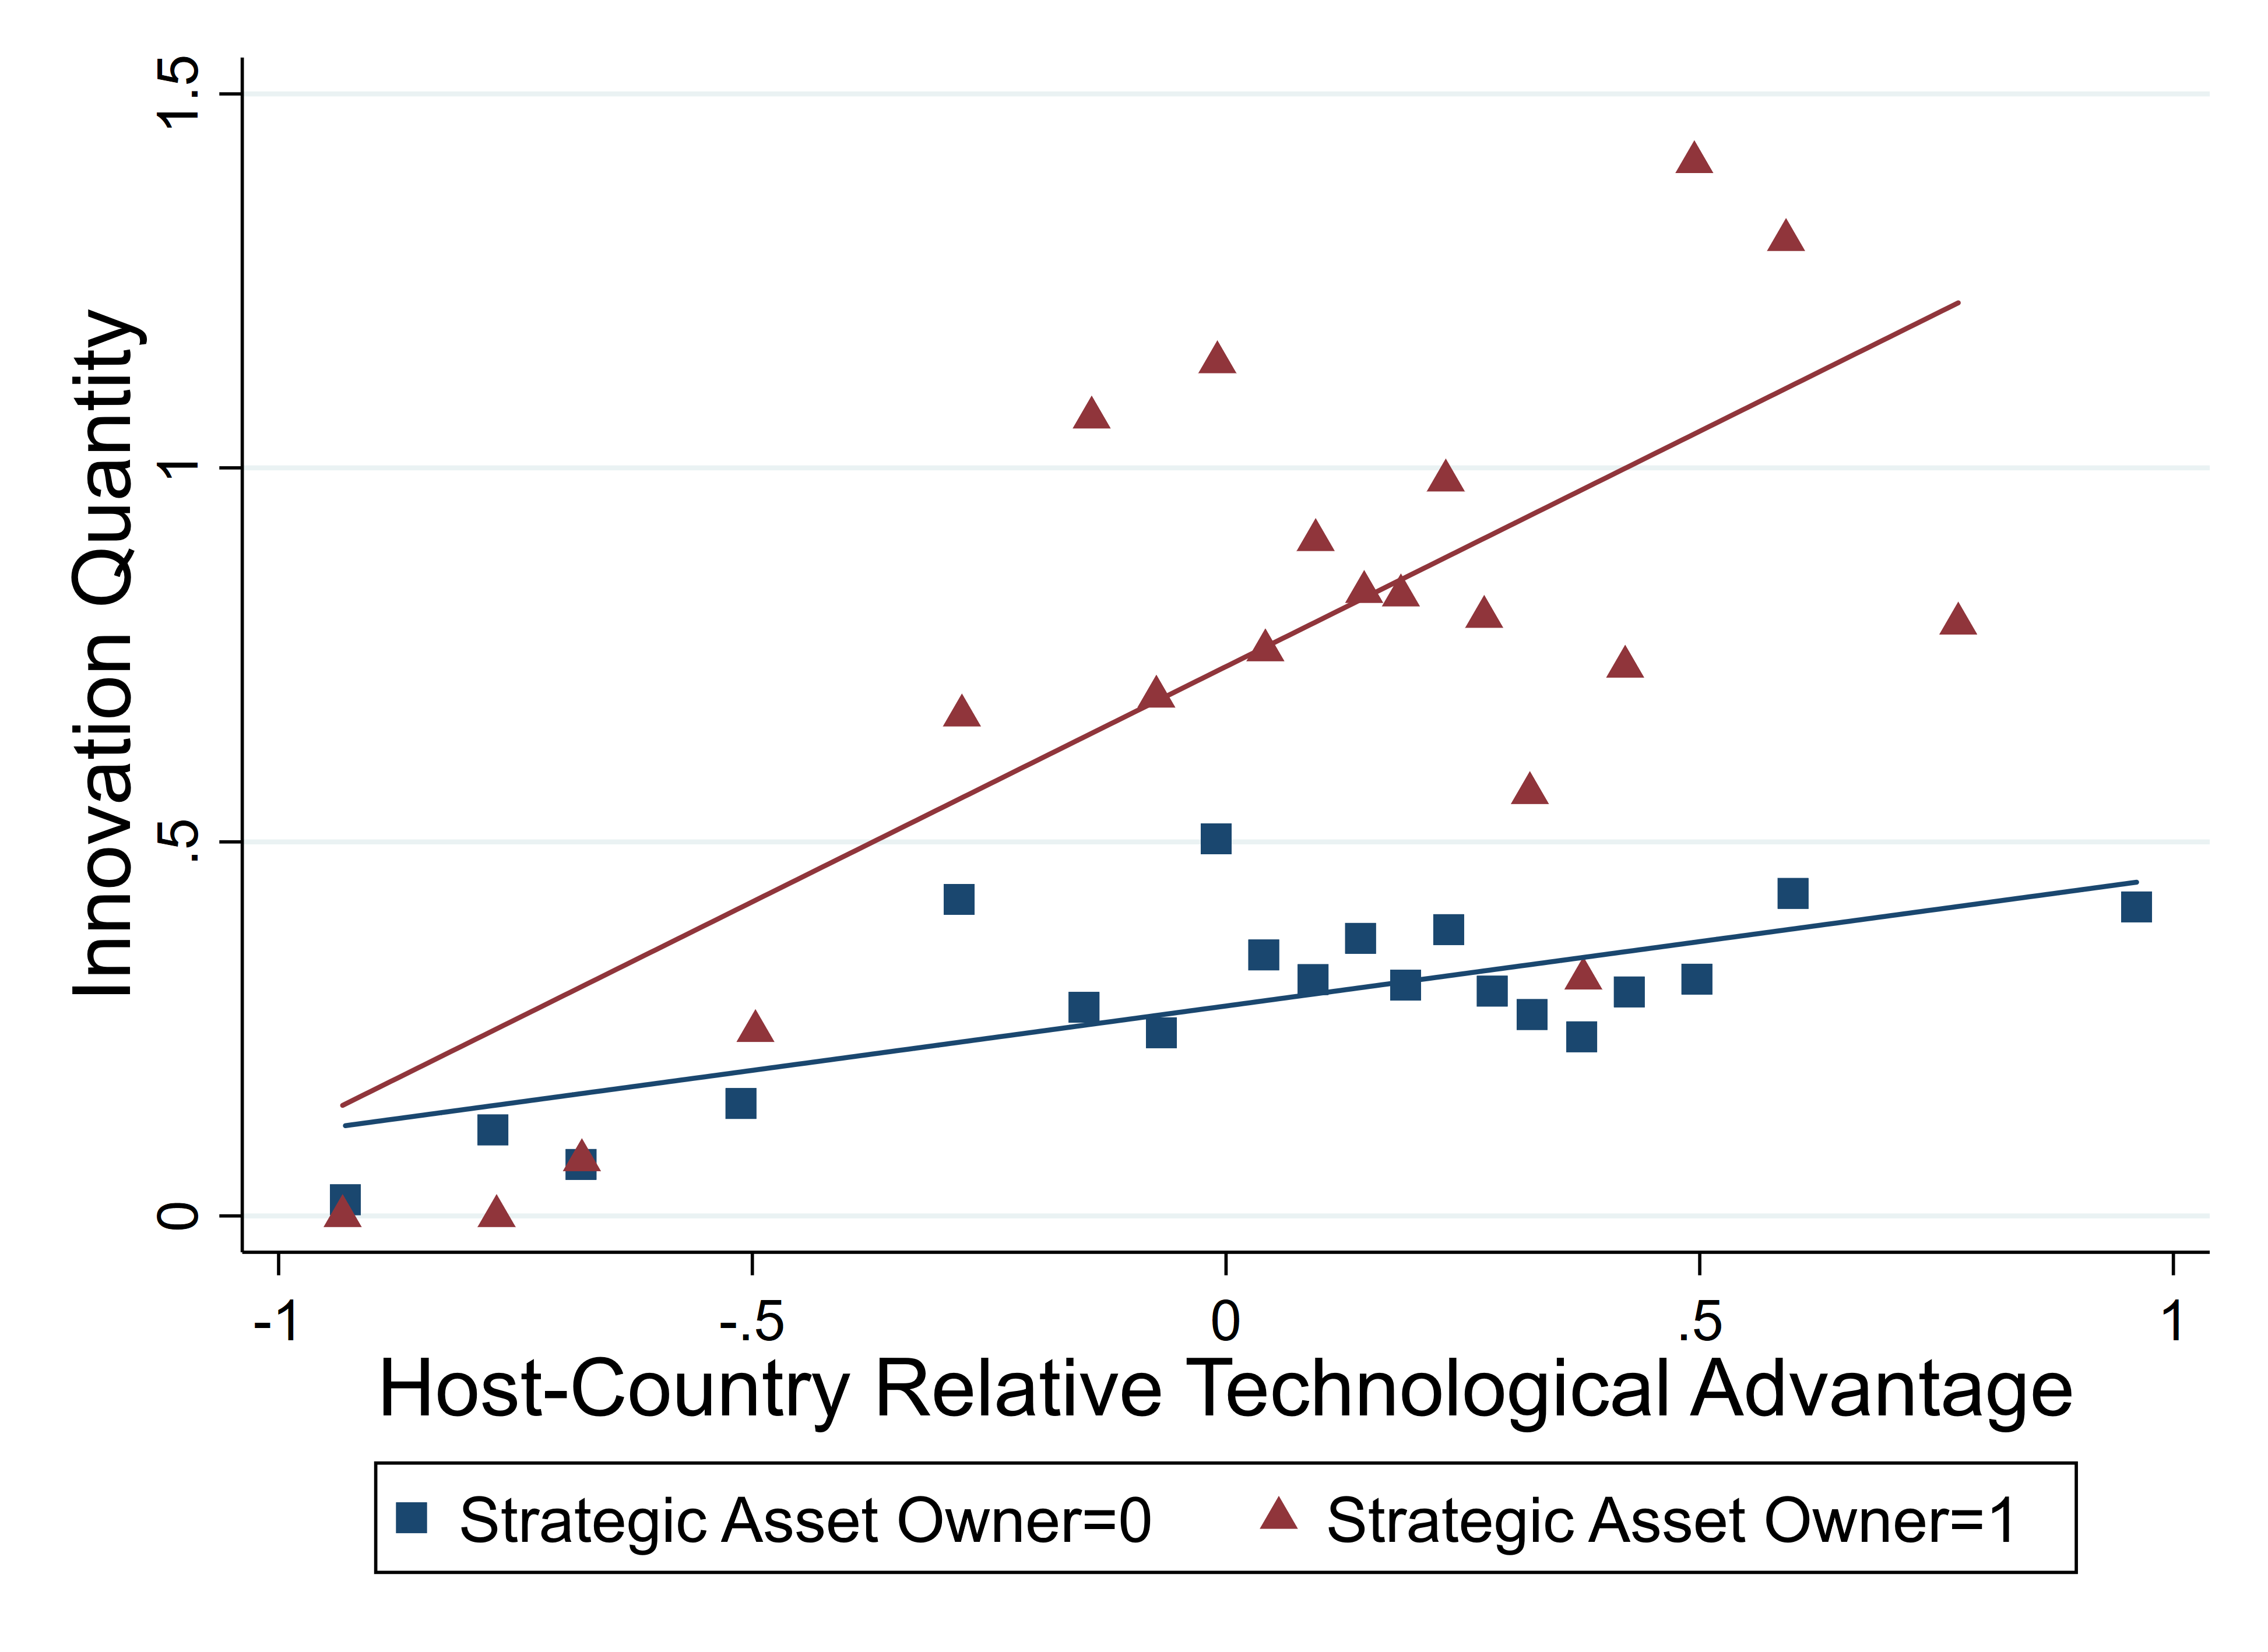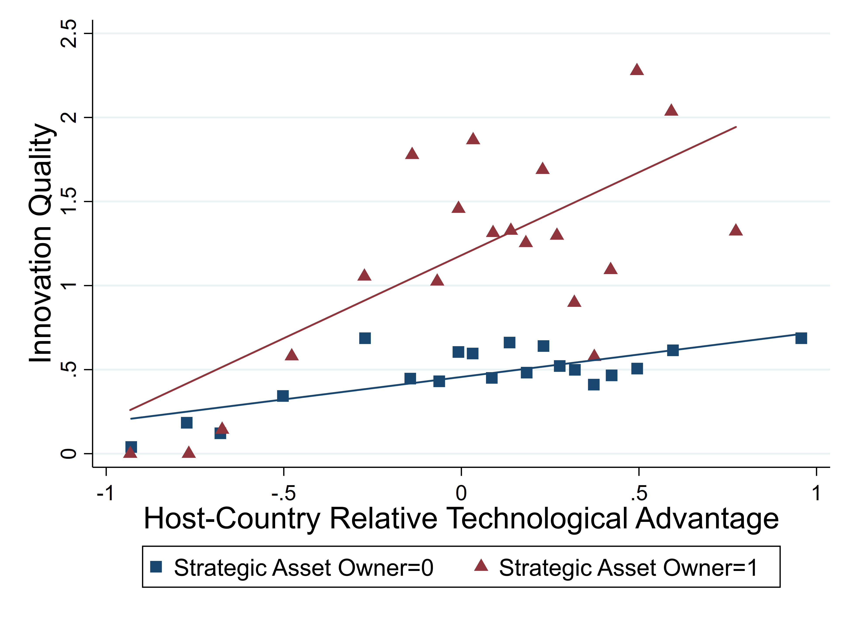
Figure 1. Binscatter plots of the relationships between technological innovation outcomes, host-country relative technological advantage, and strategic asset ownership

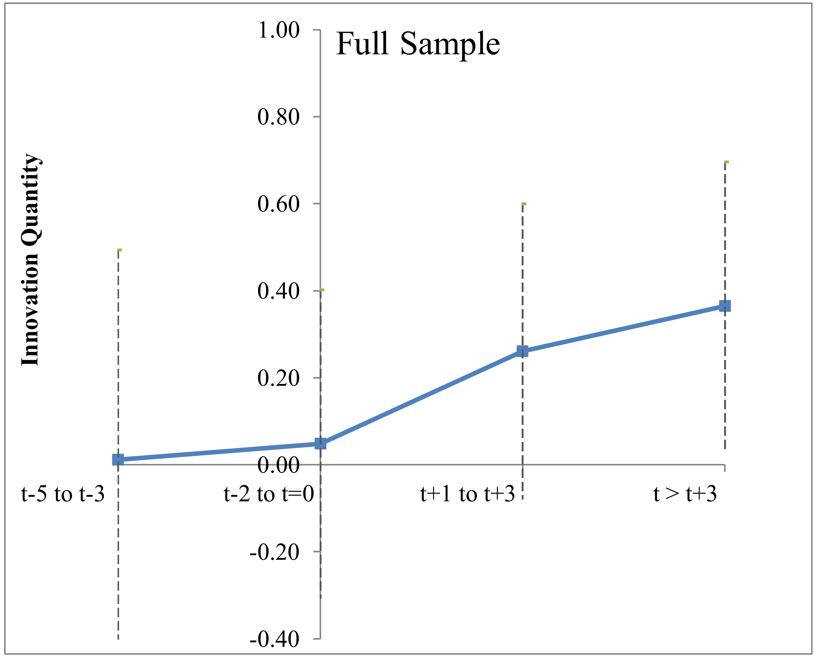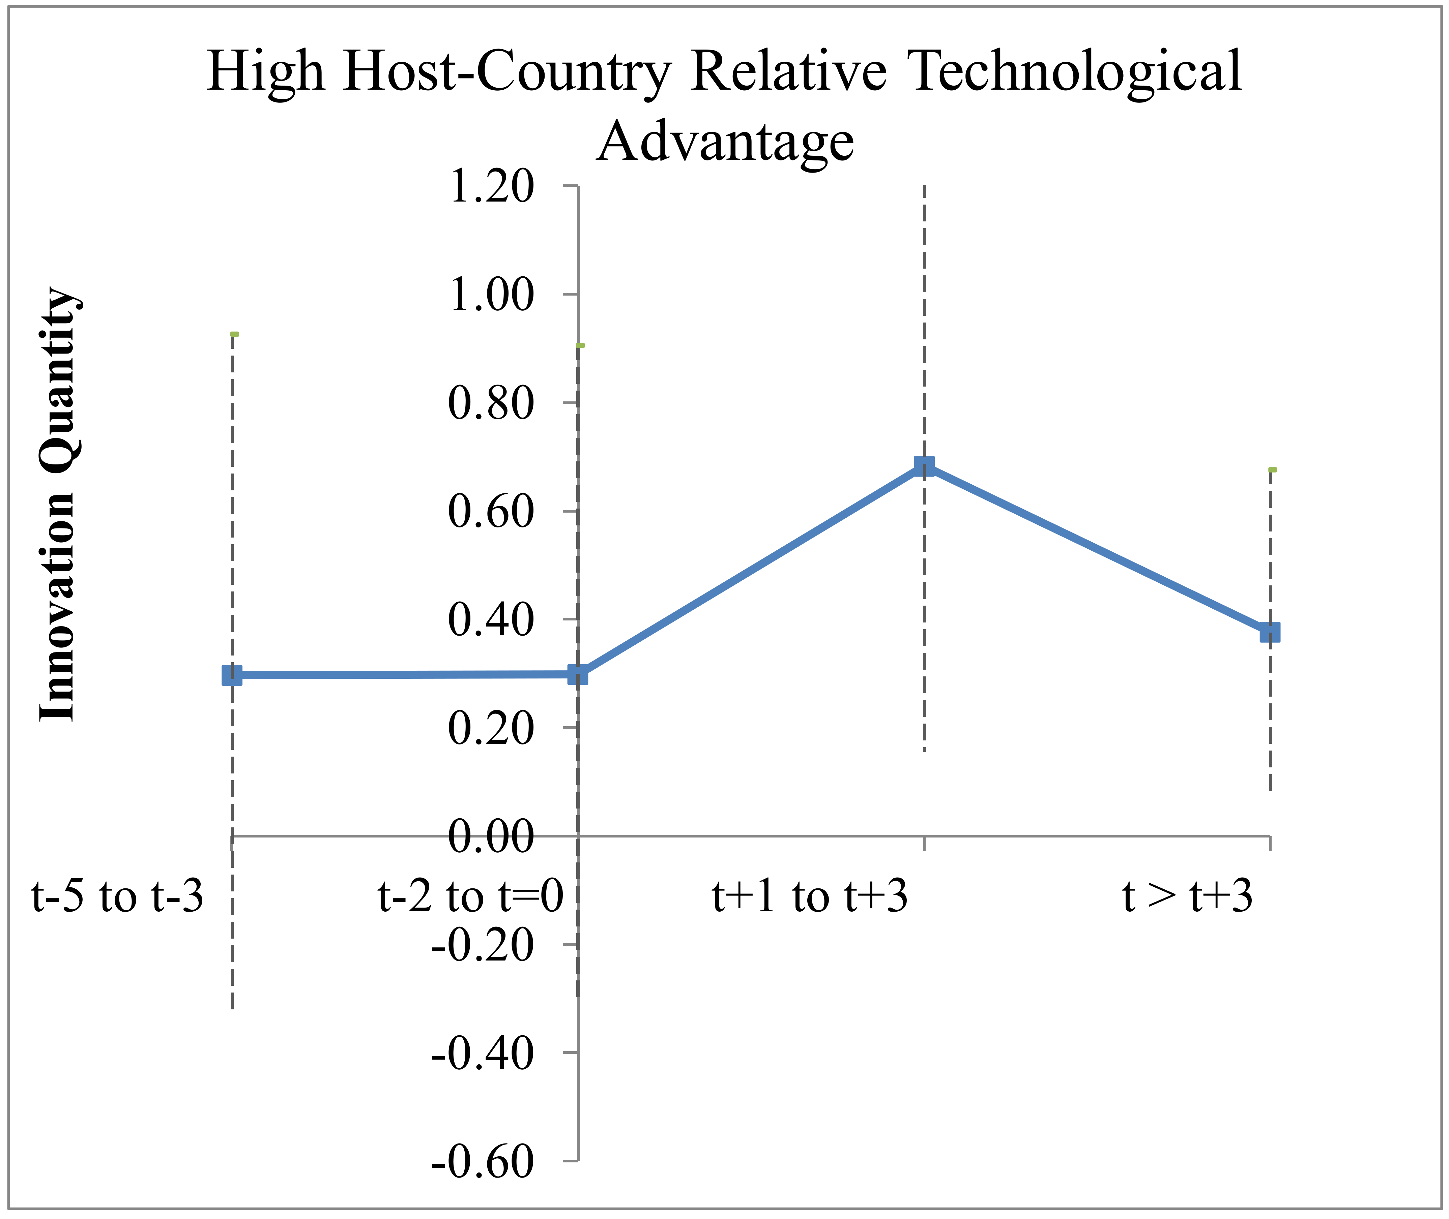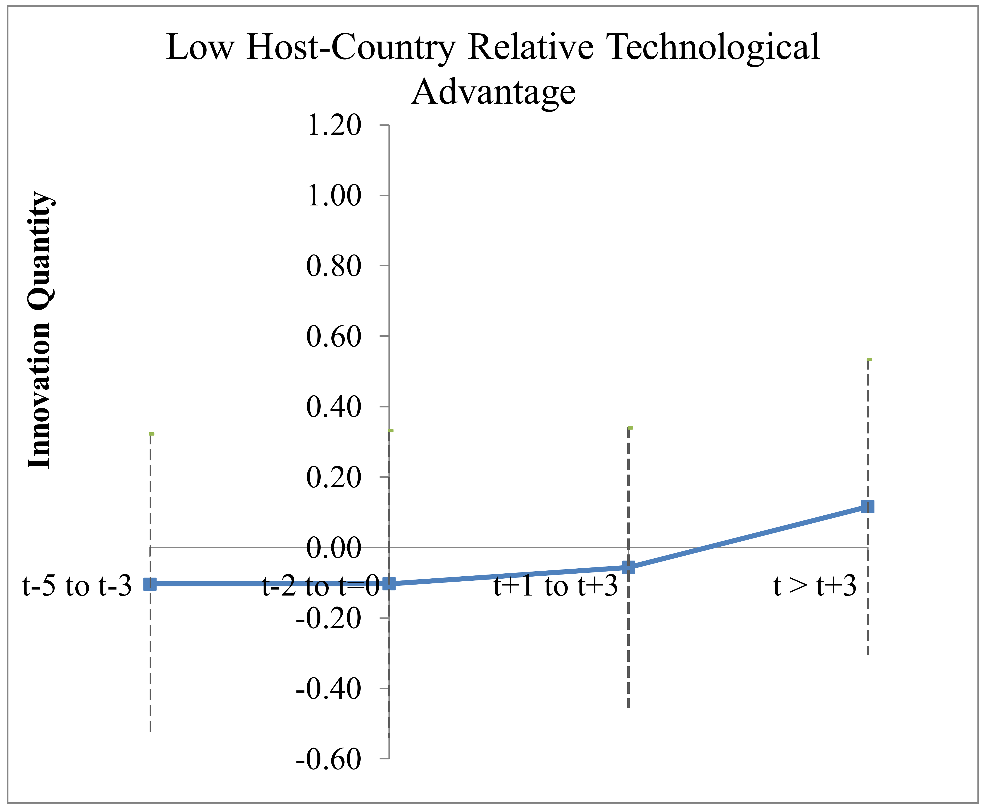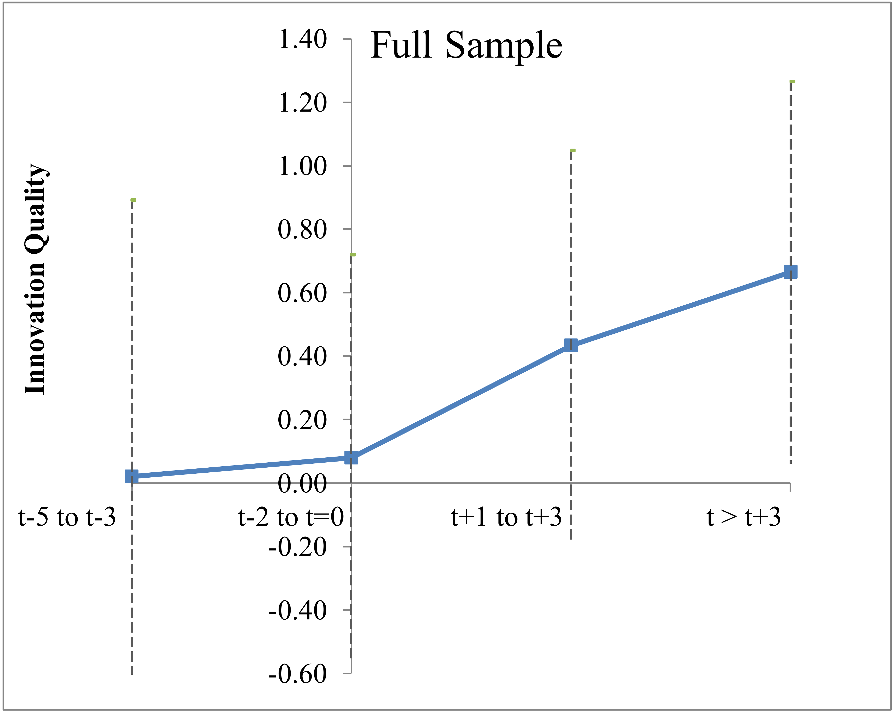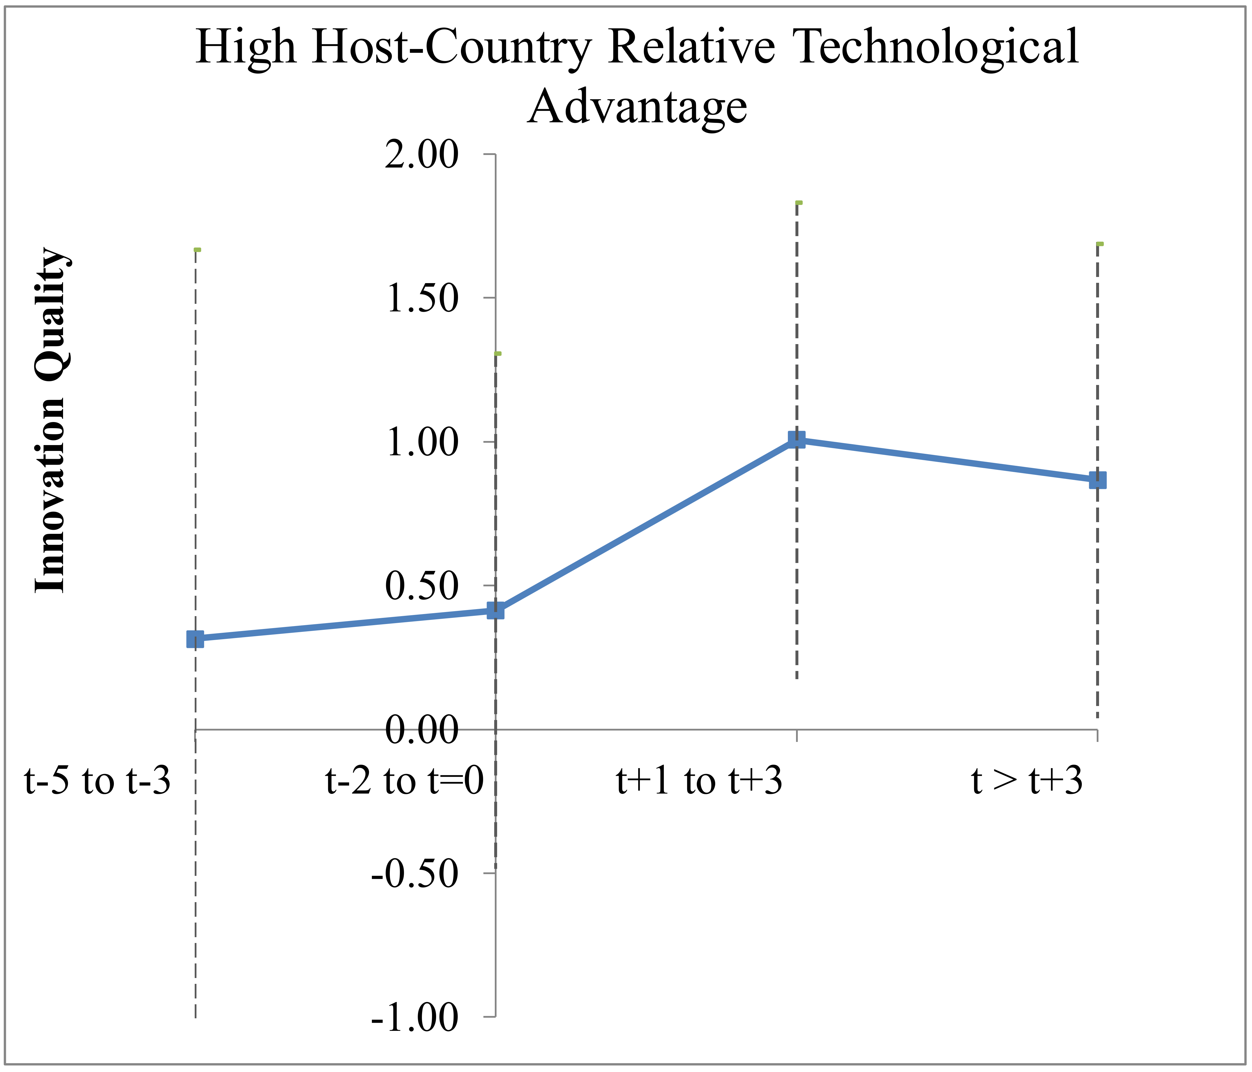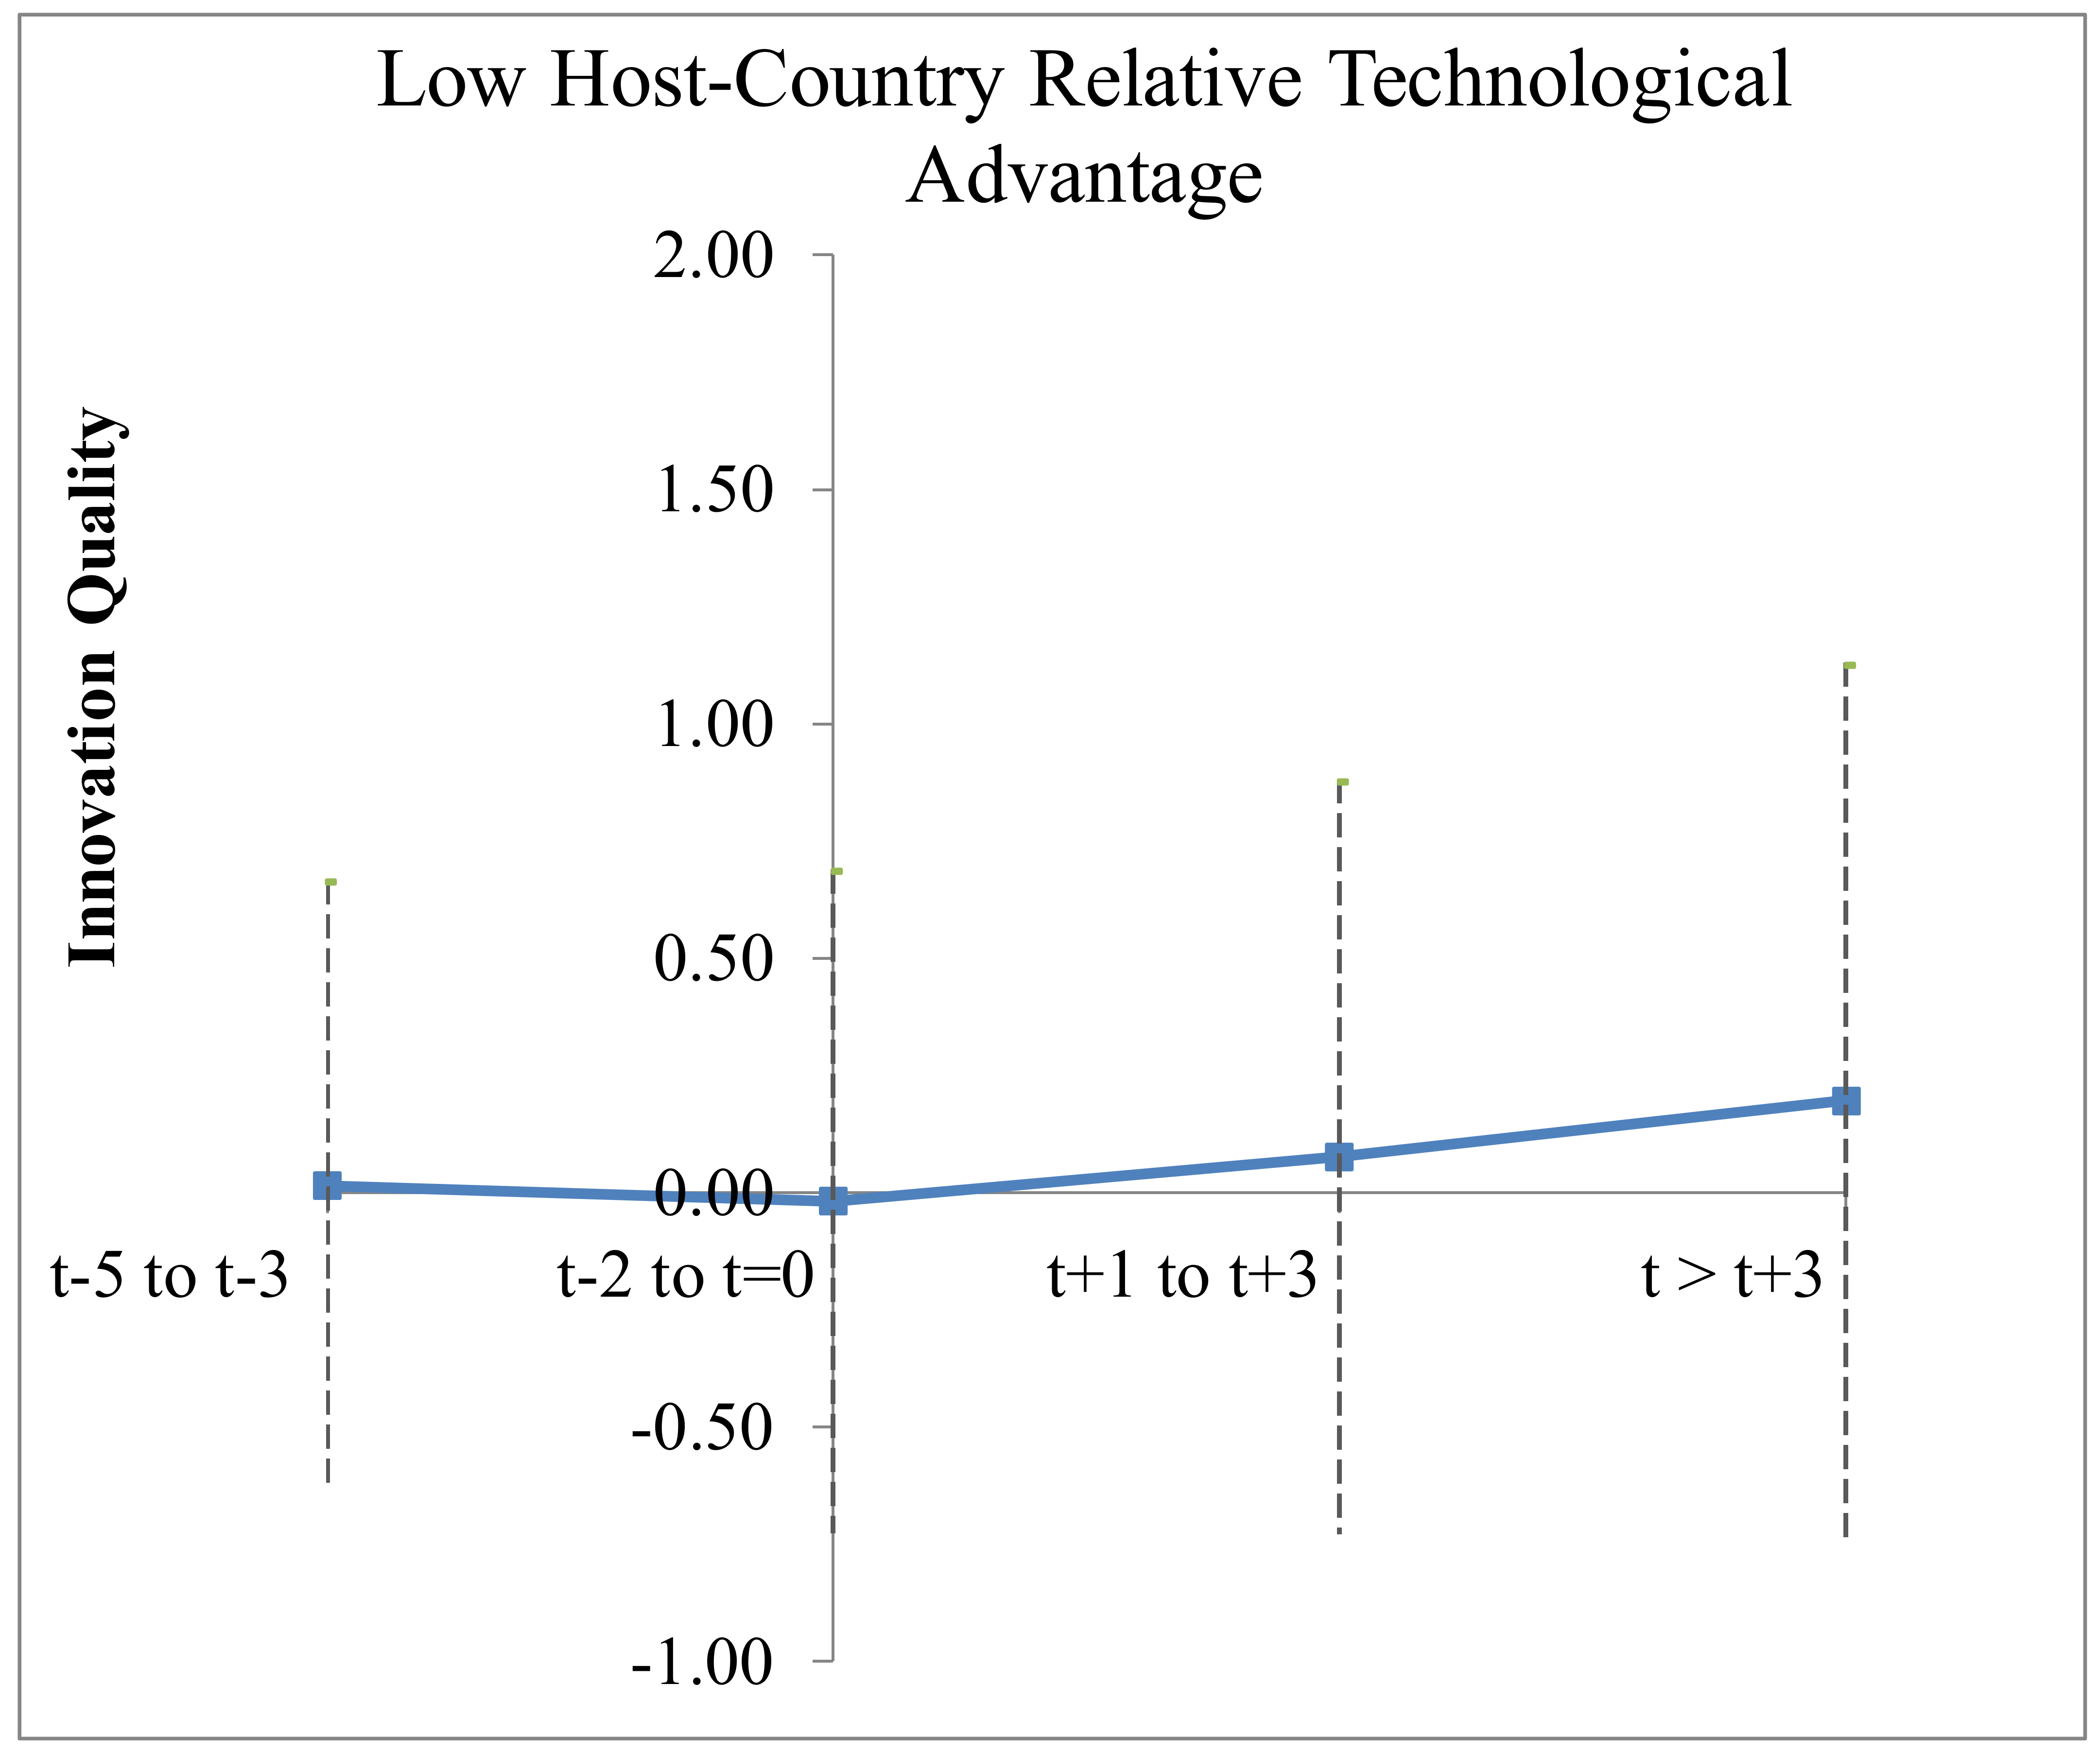
Notes. The graphs above are based on the specifications of Models 5-7 (graphs in the first row above) and Models 12-14 (graphs in the second row above) in Table 5, with the Strategic Asset Owner*Post-Change split into multiple periods as indicated. Each point on the graphs represent the coefficient value of the Strategic Asset Owner*Post-Change binary indicators. The dashed lines represent the 95% confidence interval. The confidence intervals are larger in the figures than in the estimates in Table 5 due to the reduced degrees of freedom since the Strategic Asset Owner*Post-Change variable is split into multiple periods.
Figure 2. DDD pre-treatment trends for innovation output

Appendix
Example of Clauses Contained in Internal R&D Contract

[Subsidiary A] grants to [Subsidiary B] the non-exclusive right to use, develop, and enjoy the Intangible Property for the purpose only of completing the Project, subject to the terms and conditions of this Agreement and not for any subsequent manufacture of Products.

[Subsidiary B] shall not assign, sublicense, make available, or otherwise transfer any right to use, develop, or otherwise enjoy the Intangible Property without the express written consent of [Subsidiary A].

[Subsidiary B] shall promptly undertake each Project…and shall use its best efforts to complete the Project in accordance with the specifications and directions of [Subsidiary A].

[Subsidiary B] shall provide monthly reports to [Subsidiary A] on the progress that has been made with respect to the Projects. Each Report shall contain…

[Subsidiary B] acknowledges [Subsidiary A]'s exclusive right, title, and interest in and to the Intangible Property. [Subsidiary B] shall not at any time do or cause to be done, or fail to do or cause to be done, any act or thing, directly or indirectly, contesting or in any way impairing [Subsidiary A]'s right, title, or interest in the Intangible Property. Every use of any Intangible Property by [Subsidiary B] shall inure to the benefit of [Subsidiary A].

[Subsidiary A] shall at all times, during or after the term of this Agreement, be the sole owner of all rights relating to or emanating from Intangible Property, Know-How, Improvements, or other matters developed in, or related to, a Project.

Payment by [SUBSIDIARY A]. Each Report shall identify the Development Costs that have been incurred by [Subsidiary B] in respect to each Project during the period covered by such Report.

[Subsidiary A] shall reimburse [Subsidiary B] for such Development Costs together with a mark-up equal to XX percent (XX%) of such costs. The [Subsidiary A] shall pay the [Subsidiary B] in accordance with Schedule 2, as amended from time to time by agreement between the parties. Payment shall be due on submission of each report and payable within 90 days of such submission.

Governing Law. This agreement shall be shall be governed by and construed in accordance with the laws of [Subsidiary B host-country].

This study focuses on the property rights concept of economic ownership rights, which are the rights to control the assets and the rights to income or losses from the assets (Grossman and Hart, 1986). While economic ownership may overlap with equity and legal ownership, it is conceptually distinct. Barzel (1997) argues that economic ownership rights are the ends that agents seek whereas legal rights are the means to achieve the ends.
A firm is defined hereafter as a MNE. A subsidiary is any legal entity wholly owned by the MNE. While the parent holds legal ownership over subsidiaries, property rights creates a sub-hierarchy of strategic asset ownership rights.
Governments lose an estimated $100 to 240 billion in tax revenue each year from MNEs shifting income from high to low tax jurisdictions (OECD, 2015), half of which is attributed to R&D strategic assets (Grubert, 2003).
Baker et al. (1999) predict that if it is crucial for a business unit or subsidiary to hold ownership rights to the asset, the firm will spin off that business unit or subsidiary.
Licensing is another type of contractual relationship within the firm. Less than three percent of R&D subsidiaries in the dataset license the rights to develop strategic assets. Since there are relatively few licensing relationships associated with innovation activities, licensing arrangements are outside the scope of this study.
Control and income rights are typically held together, with the exception of pure tax haven subsidiaries, which do not perform functions and have no or minimal employees, in which case, the parent typically controls the strategic assets and the tax haven entity keeps the profits. The OECD has recognized that this creates a separation between income and control and has targeted the separation between income and control as tax avoidance in the Base Erosion and Profit Shifting project.
Tracking subsidiary performance can enhance the effectiveness of other incentives, such as career and compensation incentives. Budd, Konings, and Slaughter (2005) provide evidence that subsidiary profitability can help to justify large wage payments to management and workers.
If the Japanese subsidiary did not hold ownership rights, and instead was contracted to perform innovation on the product technology, it would perform R&D under the direction of owner, would not coordinate and manage other subsidiary activities, and would receive a return on its R&D costs, which in this case would be $3.45 million.
Formalization—the extent to which decision making is routinized in rules and procedures—is another mechanism for controlling subsidiary innovation. However, formalization is less important for innovation activities that require creativity and non-routine decision processes (Ambos and Shlegelmilch, 2007; Nobel and Birkinshaw, 1998).
In interviews with MNE executives and experts, the transfer of subsidiary ownership rights was often cited as prohibitively costly. Often, the decisions regarding ownership rights to a strategic asset are large, one-time decisions. In general, any transfers of strategic assets occur with MNE restructurings, strategic changes, or M&As.
A limitation to this analysis is it relies on USPTO, not global patent data. However, it is common practice to use patent data from one patent authority due to differences in the data from different patent offices (Jaffe and Trajtenberg, 2002). While the USPTO data can have a bias towards U.S. MNEs and U.S. subsidiaries, firms active in the U.S. have an incentive to file for intellectual property protection in the U.S. As 71 percent of the MNEs are headquartered in the U.S., and all MNEs in the dataset have at least one location in the U.S., the bias should be somewhat alleviated by the fact that all MNEs in the sample have an incentive to patent with the USPTO.
Including these more complicated rights observations does not change the results.
The reports are audited by tax authorities. If any discrepancies from the facts are found in the reports, firms face significant penalties and, in some countries, criminal charges against executives. Governments on both sides of internal transactions (e.g. buyer and seller) may audit the transaction.
The reports document ownership rights based on information from the written contracts between MNE entities (see, e.g., contract clauses in the Appendix), payment and transaction flows, and interviews with management.
The R&D subsidiaries with strategic asset ownership rights generally own the strategic assets they create.
Since subsidiary size is directly affected by strategic asset ownership and is highly correlated with other variables in the analysis, subsidiary size is excluded as a control.
Ideally, an exogenous shock that changes subsidiary ownership rights could be used to observe changes in subsidiary innovation pre- and post-ownership change. However, ownership rights do not change often. There are only 24 instances of change in the entire sample, which makes it difficult to draw statistical conclusions.
Several countries had a stepwise increase in R&D tax subsidies over several years. For these cases, I rely on the first significant increase in R&D tax subsidy to code the post-change binary variable. For countries that decrease the R&D tax subsidy, the post-increase variable is set equal to zero if the year is after the decrease in R&D tax subsidy. For instance, France is one of the countries with the most variation in R&D tax subsidies in the sample. France increased its R&D tax subsidies from 0.06 in 2003 to 0.13 in 2004 and 0.21 in 2006. The years 2005, 2006, and 2007 are coded as post-change in R&D tax subsidy. In 2007, France dropped its R&D tax subsidies to 0.19 and therefore the post-change variable is coded zero in 2008. France then increased its R&D tax subsidy to 0.34 in 2008, so I code the post-change in R&D tax subsidy variable as one for the years after 2008.
Host-country RTA and subsidiary R&D expenses are excluded since they can be affected by R&D subsidies.
Separate binary indicators for strategic asset owner and whether the subsidiary is in a location of R&D subsidy increase (treated) are not independently included in the estimation as they are absorbed by subsidiary fixed effects.
Of the non-owners, 40.0 percent were contracted by the parent and 84.5 percent were contracted by subsidiary strategic asset owners to perform R&D (subsidiaries may contract with multiple strategic asset owners).
Consistent with the idea that MNEs balance trade-offs, 52.1 percent of strategic asset owner observations are in the high host-country RTA sample and 47.9 percent are in the low host-country RTA sample.
Estimating a difference-in-differences analysis on a subsample containing only non-owners and using a binary indicator for post-R&D tax subsidy yields consistent results.
Matched sample balancing t-tests for the variables indicated no significant owner and non-owner differences.
I replaced MNE size with MNE age and diversification, and included MNE fixed effects for both analyses and included host-country RTA (which can be affected by R&D tax subsidies) in the DDD analysis.

