Corporate Social Counterpositioning: How Attributes of Social Issues Influence Competitive Response
Aharon Cohen-Mohliver; Donal Crilly; Aseem Kaul

ONLINE APPENDIX A: FORMAL MODEL
In what follows, we develop a formal mathematical model to explore how the equilibrium investments of firms are impacted as we vary the salience and agreement of the issue they are seeking to address.

Consumer market competition
To keep our model tractable, we focus on a single stakeholder group—consumers—and on a single market—the market for firms’ products—as the arena of inter-firm competition. Our focus on a single stakeholder group is consistent with the development of formal theory in this area (Heyes & Martin, 2015; Morgan & Tumlinson, 2019), as is our focus on consumers as the focal stakeholder group (Fosfuri et al., 2015). We believe the general insights from our model may be extrapolated to other stakeholder groups—employees, regulators, investors—that firms may seek to please through CSR efforts (Dorobantu et al., 2017, Luo & Kaul, 2019).
We model consumer market competition as a differentiated duopoly (Singh & Vives, 1984; Zanchettin, 2006). As discussed, we choose this model because it has been used in prior nonmarket strategy research (Baron, 2001, Melloni et al., 2019, Kaul & Luo, 2018). Consider two profit-maximizing firms, $A$ and $B$, competing in a consumer market.
The (exogenously determined) utility function of the representative consumer is:
$$U=α\left(q_{A}+q_{B}\right)-\frac{1}{2}\left({q_{A}}^{2}+{q_{B}}^{2}+2γq_{A}q_{B}\right)+m$$
Where $q_{A}$ and $q_{B}$ are the quantities sold by firm $A$ and firm $B$ respectively, and $m$ is a numeraire good (Kaul & Luo, 2018). The parameter $α$ is the intercept of each firm’ inverse demand curve and thus reflects the marginal utility to the average consumer of the first unit of the firm’s good she consumes (Zanchettin, 2006; Kaul & Luo, 2018). The parameter $γ$ captures the extent to which the offerings of the two firms are seen as substitutes for each other, with $0≤γ≤1$ (Zanchettin, 2006). If $γ=1$, the two offerings are perfect substitutes; if $γ=0$, the two offerings are entirely independent, and each firm is, in effect, an independent monopoly.
On the supply side, both firms incur an identical and constant variable cost of $c$ with each unit they sell, where $α>c$, i.e., firms can make a profit by supplying the market. For simplicity, we assume no fixed costs. Firms are assumed to engage in Cournot competition, i.e., to choose the optimal quantities to supply in order to maximize their overall profits. The realized prices corresponding to the chosen quantities are $p_{A}$ and $p_{B}$ for firms $A$ and $B$ respectively, and their profits are thus given by $π_{A}=(p_{A}-c)q_{A}$ and $π_{B}=(p_{B}-c)q_{B}$.
CSR benefits and costs
In addition to engaging in quantity-based competition, firms may also compete by undertaking CSR: by taking a stand or adopting a practice related to a social issue. In line with our theoretical arguments in the main paper, we characterize every social issue using two parameters. First, we consider the salience of the issue as the additional utility the average consumer derives when buying from a firm that undertakes CSR in line with her position. We assume that the average consumer derives (and is willing to pay for) an additional utility of $αϕ$ for every unit of such a firm’s offering she consumes. $ϕ≥0$ is thus a parameter for the salience of the issue, with higher values of $ϕ$ corresponding to issues that consumers care more about. For purposes of exposition, we only consider values of $ϕ≤1$ in the discussion that follows, though the results are unchanged if we consider higher values of $ϕ$.
Second, we consider the level of agreement among consumers on the issue. Specifically, we introduce a parameter $λ$, defined as the proportion of consumers who hold the majority position on the focal issue. Clearly, $0.5≤λ≤1$, with higher values of $λ$ indicating that the majority position has more or less unequivocal support, while values of $λ$ closer to half imply that similar numbers of consumers hold positions for the issue as those who hold positions against it.
For the purposes of our main model, we assume that the parameters $ϕ$ and $λ$ are exogenous, meaning that firms cannot influence the salience of the issue or its level of agreement. What firms can do is undertake CSR in support of one side of the issue. Doing so makes the firm’s offering more valuable to those whose position on the issue it supports ($λ$ of all consumers), since they receive additional utility (equal to $αϕ$) when buying from a firm that shares their position. At the same time, it makes the firm’s offering less valuable to those who oppose its position. Such consumers may see buying from such a firm as a betrayal of their values, and will choose to boycott the firm’s offerings. By supporting the majority position through its CSR, a firm thus limits its effective market to a fraction $λ$ of consumers.
In addition to the opportunity cost of lost sales to those who oppose its position, CSR may raise the operating costs of the firm. Specifically, we assume that undertaking CSR raises the cost of the firm’s operations by a factor $τ$, so that the (variable) operating cost of a firm undertaking CSR is $c(1+τ)$. This increase may reflect the cost of operating more responsibly—e.g., higher input costs from responsible sourcing or increased expenditures on pollution abatement—or it may represent the cost of cash donations or volunteer hours. Clearly $τ≥0$. If $τ$ is equal to or close to 0, then the firm’s CSR efforts are largely symbolic (Hawn & Ioannou, 2016; Kaul & Luo, 2018), meaning that the firm claims to support a cause without investing substantial resources in it or changing its internal operations. Examples of such symbolic actions include statements of support for a cause by a firm or its CEO, or the hiring of a few token employees. As $τ$ increases, the firm’s CSR efforts may be thought of as increasingly substantive, involving real change to its operations or meaningful contributions of money and other resources to support a social cause. We may thus think of $τ$ as a measure of the substantiveness of firms’ CSR activities. While there is no upper bound on $τ$, a profit-maximizing firm will never pursue CSR if $τ>\frac{αϕ}{c}$ since in that case the margin it earns per unit will fall with CSR. For simplicity, we assume no fixed costs of pursuing CSR, though we return to this assumption later. We also assume that the firm considers a given CSR action on the focal issue—potentially dictated by the demands of activists or the structure of opportunity—so that its choice is limited to undertaking CSR or not and it cannot adjust the cost of CSR by doing less or more of it.
Sequence of decisions and model solution
We assume that firms first decide sequentially on their CSR commitments—specifically, we assume, without loss of generality, that firm $A$ moves first and decides whether to stay neutral or to undertake CSR for the majority position and then firm $B$ decides whether to emulate (i.e. also invest in CSR for the majority), ignore (i.e., stay neutral), or oppose (i.e., invest in CSR for the minority) firm $A$’s action—and then simultaneously engage in product market competition (which, as previously mentioned, we model as a Cournot game). The intuition is that CSR commitments, being relatively sticky, may be pre-determined, relative to the choice of quantities sold in the market.
To solve the game, we work by backward induction. Specifically, we first calculate the equilibrium quantities and profits for both firms under all plausible scenarios. To do so, we consider the general form of the inverse demand curve for the two firms:
$$p_{A}=a_{A}-b_{A}q_{A}-dq_{B}; p_{B}=a_{B}-b_{B}q_{B}-dq_{A}$$
The equilibrium quantity and profit for firm $A$ is then given by:

$q_{A}^{*}=\frac{2b_{B}\left(a_{A}-c_{A}\right)-d(a_{B}-c_{B})}{4b_{A}b_{B}-d^{2}}$; $π_{A}^{*}={q_{A}^{*}}^{2}b_{A}$

Appendix tables A.1 and A.2 show the specific inverse demand curves and equilibrium quantities in each of the four cases, respectively.
We then use these to determine the best (i.e., profit-maximizing) response of firm $B$ to firm $A$’s choice to invest in CSR or stay neutral. Finally, we determine whether firm $A$ is better off investing in CSR or staying netural, given firm $B$’s (correctly) anticipated reaction and the resulting profits firm $A$ stands to make.
Salience, agreement, and competitive equilibrium
This analysis produces four possible outcome scenarios: neither firm undertakes CSR (Case I); one firm undertakes CSR, taking the majority position, while the other stays neutral (Case II); both firms undertake CSR but take opposite positions (Case III); and both firms undertake CSR and both support the majority position (Case IV). We represent the conditions under which each scenario prevails by determining the threshold values of salience ($ϕ$)—as a function of agreement ($λ$), competition ($γ$), substantiveness ($τ$), and other market factors—above or below which different scenarios are optimal. To arrive at these threshold values, we first define a general threshold value $ϕ^{i,j}$ such that $ϕ=ϕ^{i,j}≡{π^{*}}^{i}={π^{*}}^{j}$. Appendix Table A.3 provides the precise formula for calculating $ϕ^{i,j}$ in different cases.
These threshold values and the corresponding equilibria are depicted in Appendix Figure A.1, which corresponds to Figure 2 in the main paper.
Case I: Social indifference As discussed in the main paper, Case I arises where both salience and agreement are relatively low. Specifically, we can define a threshold $\underline{ϕ}=\min\left(ϕ_{A}^{I,II}, \overline{ϕ}\right)$ such that for values of salience below $\underline{ϕ}$, firm $A$ would be worse off if it took action in support of the majority position alone (i.e., ${π_{A}^{*}}^{II}<{π_{A}^{*}}^{I}$), and firm $B$ does not benefit sufficiently from an opposing action to make counterpositioning (Case IV) feasible (${π_{B}^{*}}^{IV}<{π_{B}^{*}}^{II}$). Given that, firm $A$ has no way of benefiting from undertaking CSR on the issue, and therefore chooses not to do so.
Case II Niche CSR For values of salience greater than $\underline{ϕ}$, ${π_{A}^{*}}^{II}>{π_{A}^{*}}^{I}$, so it is in firm $A$’s interest to undertake CSR in support of the majority position. This does not mean, however, that firm $B$ is necessarily better off following firm $A$ in its decision to undertake CSR. On the contrary, so long as the salience of the issue is below $\hat{ϕ}=min⁡(ϕ_{B}^{II, III},ϕ_{B}^{II, IV})$, which is the threshold value above which both firms are better off if they act in support of the majority position than if they do not (i.e., ${π_{A}^{*}}^{III}={π_{B}^{*}}^{III}>{π_{B}^{*}}^{I}={π_{A}^{*}}^{I}; {π_{B}^{*}}^{III}>{π_{B}^{*}}^{II}$). The area between $\underline{ϕ}$ and $\hat{ϕ}$ in Figure 1 thus corresponds to the zone (Case II) in which the issue is salient enough for it to be worth one firm undertaking CSR, but not salient enough for it to benefit both.
The fact that firm $A$ makes greater profit from undertaking CSR in this zone does not mean that it achieves a competitive advantage, however. Recall that $A$’s CSR actions do not only boost its profits. They also benefit its rival because now a set of ($1-λ$) consumers will only buy from firm $B$, which can leverage its market power over these consumers to raise its profits. More specifically, we can define another threshold value, $\dot{ϕ}=min\left(\overline{ϕ}, \frac{g_{B}^{II}-\sqrt{λ}g_{A}^{II}}{\sqrt{λ}f_{A}^{II}-f_{B}^{II}}\right)$ below which ${π_{A}^{*}}^{II}<{π_{B}^{*}}^{II}$. In the region where $\dot{ϕ}>ϕ>\underline{ϕ}$, both firms are better off if one firm undertakes CSR and the other stays neutral, but the firm that stays neutral does better than the one that undertakes CSR.
Given that, we can see that Case II actually consists of two distinct cases. Case IIa (Niche Leader) arises where $\hat{ϕ}>ϕ>\dot{ϕ}$. In this case, firm $A$ moves first by undertaking CSR for the majority position, and firm $B$ responds by staying neutral, with both firms making greater profits than in Case I, and firm $A$ making higher profits than firm $B$ on account of its first mover advantage in pursuing CSR. Case IIb (Niche Follower) arises where $\dot{ϕ}>ϕ>\underline{ϕ}$. In this case, firm $A$ first chooses to remain neutral, and firm $B$, knowing that firm $A$ is committed to neutrality chooses to invest in CSR, because by doing so it achieves higher profits than if it had stayed neutral, even though its actions result in a competitive advantage for firm $A$. Once again, both firms making greater profits than in Case I, and firm $A$ makes higher profits than firm $B$, but this time its first mover advantage lies in being able to force firm $B$ to invest in CSR. As mentioned in the main paper, this assumes that firm $B$ is convinced that firm $A$ will not invest in CSR; otherwise, we might end up with an adverse pioneering scenario where neither firm invested in CSR because both would prefer that the other went first.
Case III Counterpositioning Where salience is high but agreement is low, we have a situation where Case IV is likely to prevail, i.e., a counterpositioning equilibrium where the two firms take opposing stances. This is the case, whenever $ϕ>\overline{ϕ}$, where $\overline{ϕ}=\max\left(ϕ_{B}^{II,IV}, ϕ_{B}^{III,IV}, ϕ_{A}^{I,IV}\right)$ is the threshold value of salience above which firm $B$ profits more from opposing $A$ than joining it or staying neutral (i.e., ${π_{B}^{*}}^{IV}>{π_{B}^{*}}^{II}$ and ${π_{B}^{*}}^{IV}>{π_{B}^{*}}^{III}$), and firm $A$ is better off being opposed in its CSR than staying neutral (${π_{A}^{*}}^{IV}>{π_{A}^{*}}^{I}$). Further, $\overline{ϕ}$ is only defined if $γ>\overline{γ}$, where $\overline{γ}=2\sqrt{\frac{λ}{1-λ}}-1$. For values of $γ$ less than $\overline{γ}$, $\overline{ϕ}$ is undefined, because there is no case in which firm $B$ does better by opposing the majority position.
Case IV Universal CSR Clearly, where both salience and agreement are high, both firms may profit from acting in support of the majority position. This is the case where $ϕ>\hat{ϕ}$ (implying, as already discussed, that ${π_{A}^{*}}^{III}={π_{B}^{*}}^{III}>{π_{B}^{*}}^{I}={π_{A}^{*}}^{I}$).
Moderators and extensions
Issue substantiveness Figure A.1 shows the case of symbolic CSR, i.e., where undertaking CSR does not incur additional operating cost ($τ=0$). Figures A.2a and A.2b show the effect of moving towards more substantive CSR activities. Specifically, the picture in Figure 1 changes as we increase the operating costs of conducting CSR, with Figure A.2a showing the case where $τ=0.2$ and Figure A.2b showing the case where $τ=0.5$. Note that the latter case reflects a substantial investment in social responsibility, with the firm’s operating costs now being 50% higher as a result of its CSR efforts. As both figures show, the main effect of increasing the cost of CSR (and thus moving from symbolic to substantive efforts) is, unsurprisingly, to make CSR efforts less likely. More specifically, the two figures show a clear pattern of an increasing area under cases I and II, coupled with a decline in the area under cases III and IV, as $τ$increases.
Moderating role of market competition Whereas Figure A1.1 shows the prevailing scenarios where the two firms’ offerings were perfect substitutes ($γ=1$), Figures A1.3a and A1.3b show the prevailing scenarios where the offerings are partial substitutes ($γ=0.6$) and almost independent ($γ=0.2$), respectively. In other words, they show cases of moderate and low competitive intensity. As discussed in the main paper, they show that a decrease in the level of competition reduces the probabilities of either niche CSR (Case II) or counterpositioning (Case IV).
Heterogenous capabilities Figures A.4.1a and 1b show the prevailing scenarios when the two firms have unequal capabilities. Here, the high-capability firm has a lower cost of making an identical product (i.e., c_{A} < c_{B}), though we obtain equivalent results if we operationalize higher capabilities in terms of higher quality (and thus higher willingness to pay; i.e., $α$_{A} > $α$_{B}). If the high-capability firm moves first and claims the majority position, counterpositioning becomes more likely: the weaker firm has more to gain from distancing itself from its stronger peer, and less to lose by staying in competition. Moreover, the follower is less likely to follow the high-capability firm in taking a stand for the issue: it would rather not compete head to head with the stronger firm. For this reason, we also see an increase in the probability of niche CSR, with the weaker firm being more likely to stay neutral once the stronger firm has taken a majority stand. Conversely, if the weaker firm moves first, both counterpositioning and niche CSR become less likely: its stronger rival has more to lose by giving up the majority market, and less to fear from going head to head with the first mover. This consistent set of results adds further nuance to the notion of CSR as a basis of competition between heterogeneous firms.
Symmetric rewards and sanctions for social positioning Here, we relax the assumption that consumers boycott a firm that takes a stance they are opposed to. Instead of boycotting the firm, such consumers reduce their WTP by $ϕ$, equivalent to the additional $ϕ$ that issue supporters are willing to pay. We choose to model this perfectly symmetric case because it represents the logical opposite to the case in our main model where the penalty from ideological opponents is fixed (boycott) and salience only impacts demand from supporters In such case (Figure A.5), we find a counterpositioning equilibrium, albeit for a smaller range of values: the cost of taking a stand is now lower. In this case, the niche CSR case disappears: if it is profitable for one firm to take a stand, it is always profitable for the other to do so too, at least so long as CSR is purely symbolic (with substantive CSR one may still see vertical differentiation in CSR provision, consistent with prior economic models). In short, counterpositioning can still occur even where rewards and penalties are symmetric.

APPENDIX 1 TABLES AND FIGURES
Table A.1: Inverse demand curves
Case | $$a_{A}$$ | $$b_{A}$$ | $$a_{B}$$ | $$b_{B}$$ | $$d$$
I. Neither firm undertakes CSR | $$α$$ | 1 | $$α$$ | 1 | $$γ$$
II. Firm A undertakes CSR | $$αλ\left(1+ϕ\right)$$ | $$λ$$ | $$α$$ | 1 | $$γλ$$
III. Firm A acts for the majority, firm B acts for the minority | $$αλ\left(1+ϕ\right)$$ | $$λ$$ | $$α\left(1-λ\right)\left(1+ϕ\right)$$ | $$1-λ$$ | $$0$$
IV. Both firms undertake CSR | $$αλ\left(1+ϕ\right)$$ | $$λ$$ | $$αλ\left(1+ϕ\right)$$ | $$λ$$ | $$γλ$$
Table A.2: Equilibrium quantities
Case | Firm A | Firm B
I. | $$\frac{α-c}{2+γ}$$ | $$\frac{α-c}{2+γ}$$
II. | $$\frac{2\left(αλ\left(1+ϕ\right)-c(1+τ)\right)-γλ(α-c)}{4λ-γ^{2}λ^{2}}$$ | $$\frac{2λ\left(α-c\right)-γλ(αλ\left(1+ϕ\right)-c(1+τ))}{4λ-γ^{2}λ^{2}}$$
III. | $$\frac{2\left(1-λ\right)\left(αλ(1+ϕ)-c(1+τ)\right)}{4λ\left(1-λ\right)}$$ | $$\frac{2λ\left(α(1-λ)(1+ϕ)-c(1+τ)\right)}{4λ\left(1-θλ\right)}$$
IV. | $$\frac{αλ\left(1+ϕ\right)-c(1+τ)}{(2+γ)λ}$$ | $$\frac{αλ\left(1+ϕ\right)-c(1+τ)}{(2+γ)λ}$$
For brevity, these tables show only Case IIa, where firm $A$ undertakes CSR and $B$ does not. The corresponding values for Case IIb are easily derived by simply inverting a and b.
Table A.3 Threshold Values of Salience

$$ϕ^{i,j}=\frac{g^{j}h^{i}\sqrt{b^{j}}-g^{i}h^{j}\sqrt{b^{i}}}{f^{i}h^{j}\sqrt{b^{i}}-f^{j}h^{i}\sqrt{b^{j}}}$$

Case | $$f_{A}^{i}$$ | $$g_{A}^{i}$$ | $$f_{B}^{i}$$ | $$g_{B}^{i}$$ | $$h^{i}$$
I | 0 | $$α-c$$ | 0 | $$α-c$$ | $$2+γ$$
II | $$2αλ$$ | $$αλ\left(2-γ\right)-c(2(1+τ)-λγ)$$ | $$-γαλ^{2}$$ | $$λ(α\left(2-γλ\right)-c\left(2-γ(1+τ)\right))$$ | $$4λ-γ^{2}λ^{2}$$
III | $$2αλ\left(1-λ\right)$$ | $$2(1-λ)\left(αλ-c(1+τ)\right)$$ | $$2αλ\left(1-λ\right)$$ | $$2λ\left(α(1-λ)-c(1+τ)\right)$$ | $$4λ\left(1-λ\right)$$
IV | $$αλ$$ | $$αλ-c(1+τ)$$ | $$αλ$$ | $$αλ-c(1+τ)$$ | $$λ(2+γ)$$

Note: ${π^{*}}_{A}^{i}=b_{A}^{i}{\left(\frac{f_{A}^{i}ϕ+g_{A}^{i}}{h^{i}}\right)}^{2}$
Figure A.1: Equilibrium with maximum competition ($γ=1$), no cost ($τ=0$)

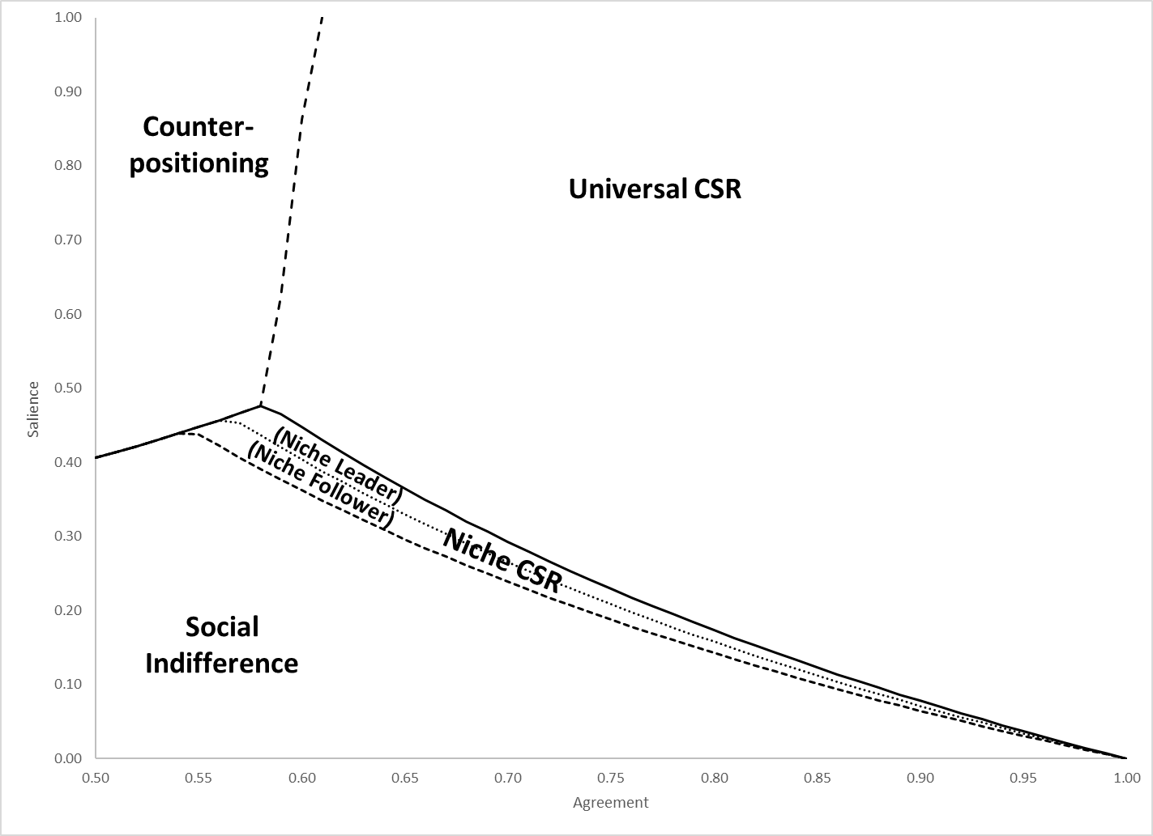

Figure A.2: Effect of CSR Substantiveness
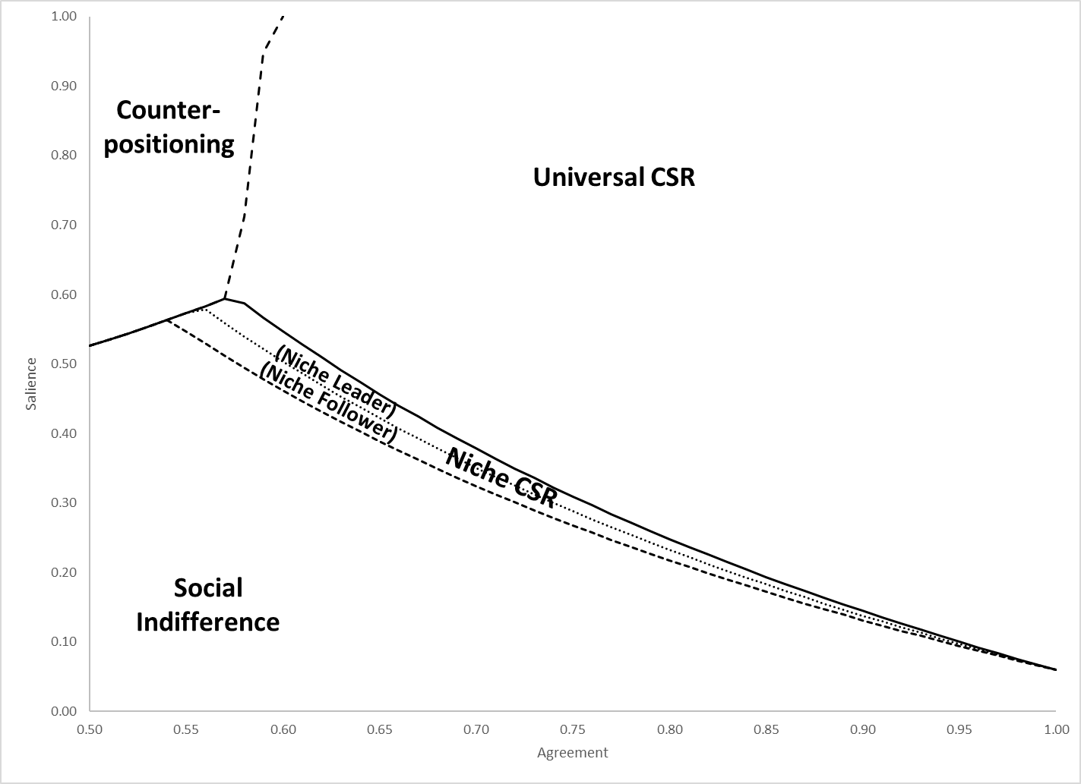
a. Moderate CSR cost ($τ=0.2)$
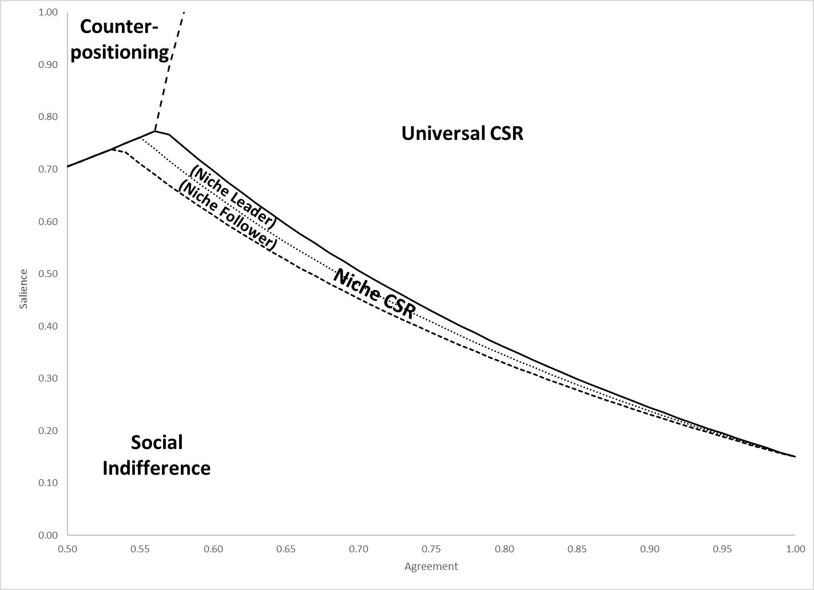
b. High CSR cost ($τ=0.5)$
Figure A.3: Moderating effect of consumer market competition
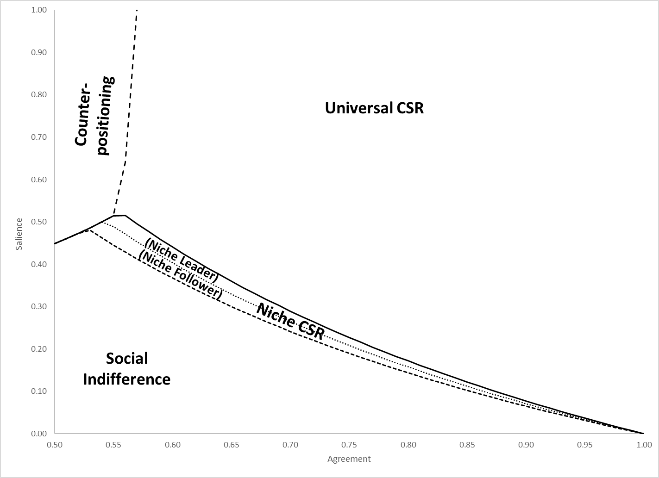
- Moderate competition ($γ=0.6$)

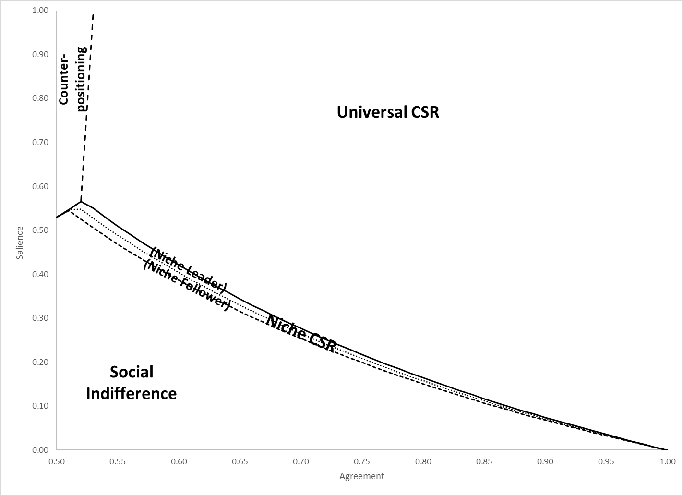
- Low competition ($γ=0.2$)

Figure A.4: Differential Capability (Lower Cost)
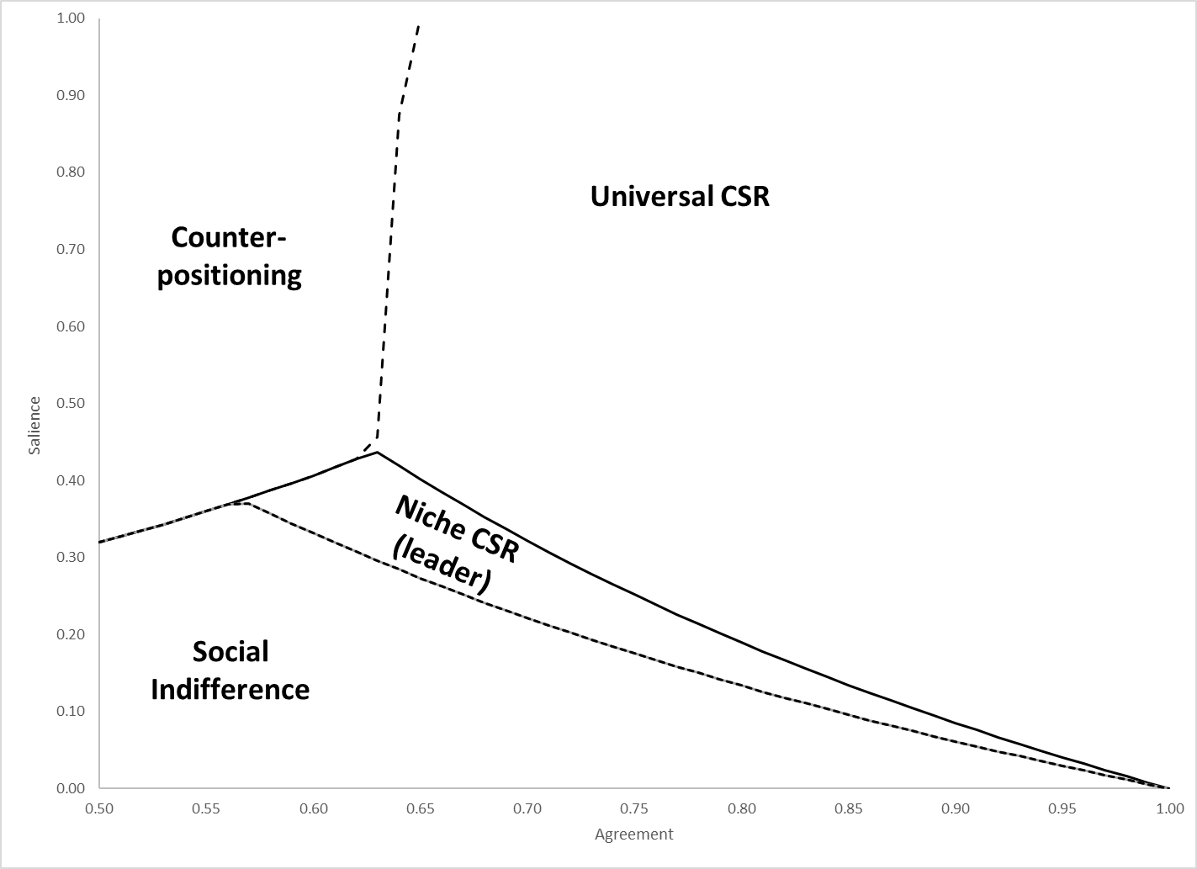
- High Capability / Low Cost firm moves first
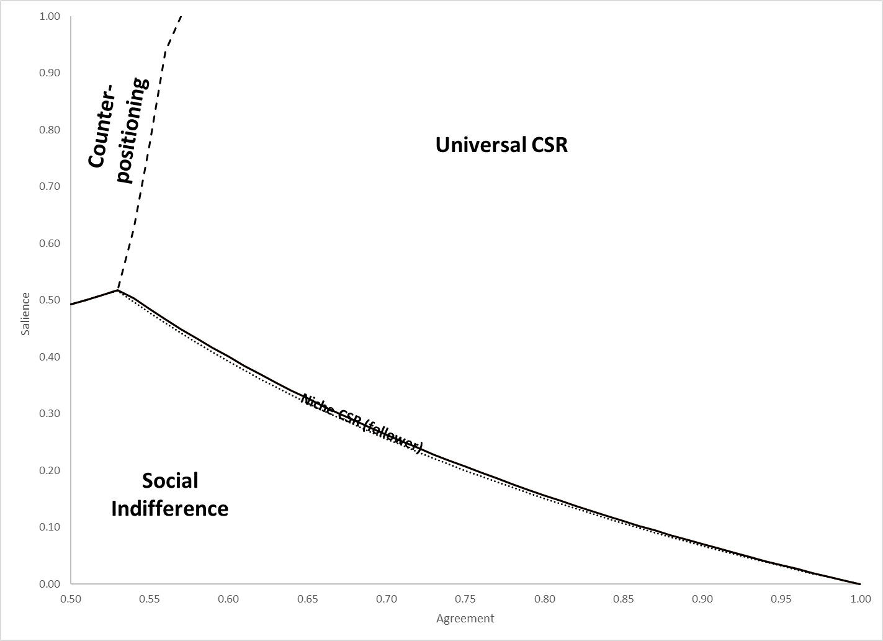
- Low capability / high cost firm moves first

Figure A.5: Symmetric Responses
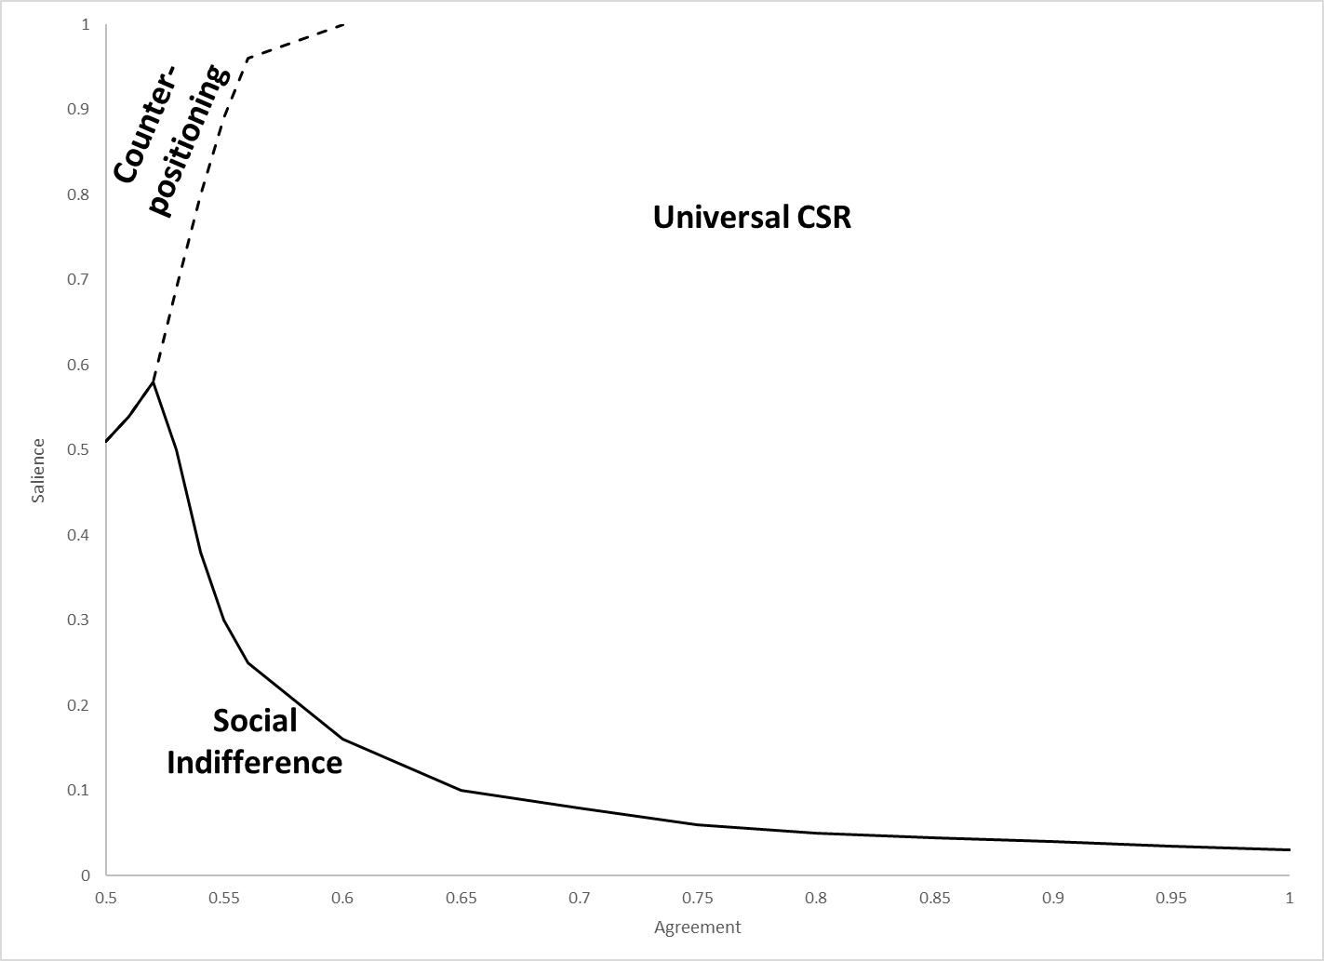

Appendix A: Additional References
Baron DP. (2001) Private politics, corporate social responsibility, and integrated strategy. Journal of Economics and Management Strategy 10(1): 7-45.
Dorobantu S, Kaul A, Zelner B. (2017) Nonmarket strategy research through the lens of new institutional economics: An integrative review and future directions. Strategic Management Journal, 38(1): 114-140.
Luo J, Kaul A. (2019) Private action in public interest: The comparative governance of social issues. Strategic Management Journal, 40(4): 476-502
Morgan J, Tumlinson J. (2019) Corporate provision of public goods. Management Science, 65(10): 4451-4949.
Singh N, Vives X. (1984) Price and quantity competition in a differentiated duopoly. RAND Journal of Economics, 15(4): 546-554.
Zanchettin P. (2006) Differentiated duopoly with asymmetric costs. Journal of Economics and Management Strategy, 15(4) 999-1015.

