Corporate Social Counterpositioning: How Attributes of Social Issues Influence Competitive Response
Aharon Cohen-Mohliver; Donal Crilly; Aseem Kaul

Online Appendix B: Measuring Issue Salience & Agreement

In this appendix, we describe two different approaches to measuring issue salience & agreement. We used these approaches to measure and compare the levels of salience and agreement for the four issues—capital punishment, animal cruelty, human trafficking, and LGBTQ rights—that we use as case examples in our main manuscript. In addition to confirming our claims as to the position of our four example issues in parameter space, this appendix thus also demonstrates how the key parameters in our model may be practically operationalized, thus showing how our theoretical model may be used for future empirical work.
Our first approach was to measure salience and agreement using platforms of political parties. This measure is useful because it allows for a measure of polarization and salience, wherein agreement over issues is highly representative of agreement in the population over these issues (Pew 2014). Furthermore, fringe issues and those that are not salient are unlikely to be overrepresented. This measure is also useful because when political parties highlight issues that differentiate the voting population, they contribute to increasing both salience and polarization on the issue. To construct a measure of issue salience and agreement, we investigated the extent to which each issue was mentioned in the 2016 programs of the Democrat and Republican parties. We counted each reference to “LGBT” (or, “marriage” in the case of the Republican program), human-related “trafficking”, “capital punishment” (or, “death penalty”), and “animals.” Subsequently, we coded whether the text was supporting or opposing the issue. We display the results of our investigation in Figure B.1, where the length of a bar represents the salience of the focal issue within the party programs, and negative scores represent opposition to the issue while positive scores represent support. LGBT rights are simultaneously salient and polarizing. Human trafficking is salient, but there is consensus in opposition to it. Animal welfare is not salient, and disagreement is not discernible. Capital punishment is a polarizing issue, but it lacks salience.
As a secondary approach, we assessed the coverage of the same issues across major U.S. newspapers over the five-year period 1 December 2015 to 30 November 2020. Informed by the AllSides rating of media bias (AllSides, 2020), we selected two right-leaning publications (New York Post, Wall Street Journal) and two left-leaning publications (New York Times, Washington Post). We noted salience by the number of articles published in the five-year window addressing each theme (Table B.1). Based on the aggregate number of articles and consistent with our first measure (party platrofms), LGBT-related topics are highly salient, whereas animal cruelty topics are much less so. Capital punishment and human trafficking lie in the mid-range. To capture agreement, we downloaded the corpus of 913 articles related to each issue the four publications and coded the sentiment of each publication’s articles per issue using the hostility category of language in the Harvard-IV dictionary. The hostility category contains 833 words indicating opposition; the measure reflects the percentage of words in a text that belong to the category. Hostility does not necessarily imply negativity towards an issue because hostile language can be used by issue proponents too. Rather, our interest lies in whether the publications converge on the same tenor. In Figure B.2, we plot the degree of hostility in each publication’s coverage. Notably, the published articles converge in their treatment of the issue of human trafficking and the issue of animal cruelty (with the exception of the Wall Street Journal, but it published only three articles on the theme). Here too, consistent with party platforms, divergence is more noticeable for capital punishment and LGBT-related issues.
Each of these methods has limitations when it comes to assessing salience and agreement – in representativeness, generalizability and sampling. Opinion polls – where respondents are prompted by the surveyor and asked to express support for or opposition to pre-determined questions are useful to assess polarization, but not salience. Media mentions and internet searches seem useful in assessing salience, but both are likely to overestimate the salience of fringe issues in which a small minority of individuals can be produce a large number of observations. Because politicians use “positional issues” to appeal to voters, political advertising and party platforms are likely to capture both salience and agreement. However, political discourse may conflate positions on one issue with positions on other issues (e.g. Baldassari & Gelman 2008). That is why we feel it is important to triangulate across both approaches when evaluating salience and agreement, as we do here.
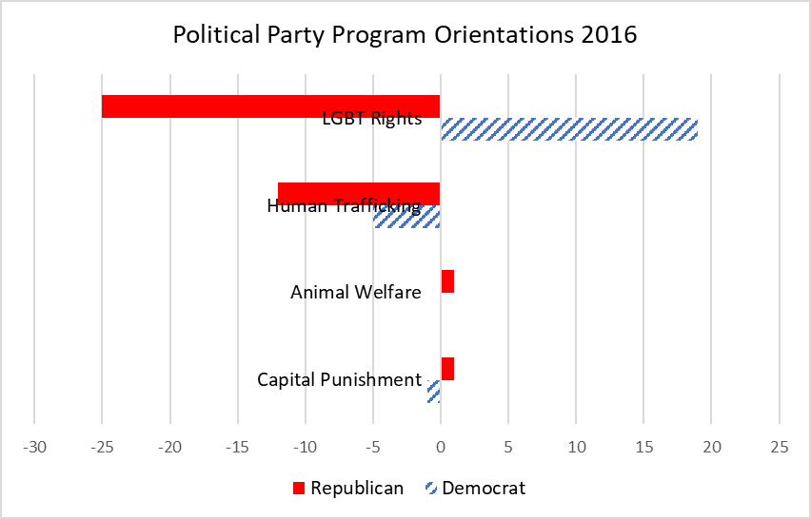
Figure B.1 Issue Salience & Agreement by Political Party Program

Table B.1 Count of issue-related articles (salience)
 | New York Post | Wall Street Journal | New York Times | Washington Post | Total
Capital punishment | 8 | 16 | 58 | 50 | 132
Animal cruelty | 29 | 3 | 20 | 22 | 74
LGBT/LGBTQ | 170 | 37 | 11 | 328 | 546
Human/child trafficking | 18 | 13 | 68 | 62 | 161

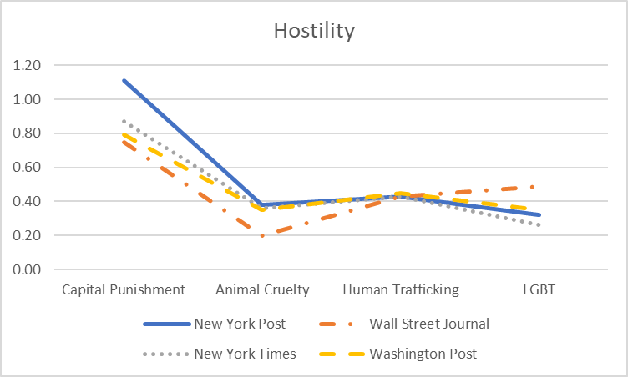
Figure B.2 Average Hostility of Articles by Newspaper & Issue (Agreement)

