Web Appendix for “When it Pays to be Clear: The Appeal of Concrete Communication under Uncertainty”

Web Appendix A: Concrete and abstract product descriptions and pretest Study 1
Web Appendix B: Descriptive statistics of Study 1
Web Appendix C: Concrete and abstract product descriptions and pretest Study 2
Web Appendix D: Descriptive statistics of Study 2
Web Appendix E: Concrete and abstract product descriptions and pretest Study 3
Web Appendix F: Study WA1 – Conceptual replication and generalization of Study 3 (additional study not included in the manuscript)

Web Appendix A

Concrete and Abstract Product Descriptions and Pretest (Study 1)
Detergent
Concrete
This new Surf detergent will make your clothes spotlessly clean. Enjoy the smell of summer freshness throughout the day. The patented Surf-Fresh formula guarantees your laundry to smell like it has been dried in the open air.

Abstract
The new revolutionary Surf detergent will strike you with its perfect cleaning results and endless freshness. It will be your faithful companion throughout the day. With its innovative formula, Surf brings you the joy of sun-kissed laundry.

Light Bulb
Concrete
Light up your day! This bulb from Eveready guarantees you bright, clear colors and glare-free light for optimal visual comfort. The Eveready light calms and relaxes you and improves your concentration.

Abstract
In the beginning there was light! This bulb from Eveready is our guarantee for glowing, natural colors, and glare-free light. Luminous effects are provided by the Eveready lightbulb, to create a calming atmosphere.

Cheese Fondue
Concrete
The cheese fondue is regarded as a Swiss national dish and provides you with a delicious meal for informal and entertaining evenings with friends. The original Swiss cheese fondue of Swiss Knight is traditionally a ready-made dish. It combines mild Gruyere and nutty Emmentaler and is refined with local white wine and kirsch.

Abstract
The popular and well-known Swiss national dish, the cheese fondue, perfectly accompanies cozy, cheerful and amusing evenings in good company. The real Swiss cheese fondue of Swiss Knight is a ready-made “feel-good dish" with carefully selected ingredients – delicate Gruyère and appetizing Emmentaler are finished of with high quality white wine and fruity aromatic kirsch.

Perfume
Concrete
This new fragrance from House of Dorin has been developed in accordance with the highest perfumery standards, using ingredients from the Far East. Green leafy notes in combination with smoky spices form a unique composition that immediately evokes a desire for more. Orange blossom, cedar and incense make the scent complete.

Abstract
This new fragrance from House of Dorin is created through a refined perfumery process and composed of precious and exotic materials. Stimulating notes complemented with exciting essences form a visionary composition, which gives every appearance “something extra”. Orange blossom in the opening and cedar and incense in the base form an opulent frame.

Note. Translated from German, original materials in German available upon request

Pretest Stimuli Study 1
Thirty students from a large German University (all native German) took part in the pretest. Participants were first introduced with the definition of abstract and concrete product communications (“A concrete product description, is a specific, factual description which is more tangible and less open for interpretation”; “An abstract product description is a vague, general description which is more difficult to verify and more open for interpretation.”). They were then presented with both the concrete and abstract descriptions of all four products (randomized) and were asked to indicate the level of concreteness on a scale ranging from 1 (very concrete) to 7 (very abstract). Results demonstrated that the concrete and abstract product descriptions of all four products differed significantly in level of concreteness, as intended. Detergent: M_{Conc} = 3.47, SD = 1.74, M_{Abst} = 4.70, SD = 1.42, t(29) = -3.15, p = .004; light bulb: M_{Conc} = 2.73, SD = 1.44, M_{Abst} = 4.00, SD = 1.68, t(29) = -2.94, p = .01; cheese fondue: M_{Conc} = 2.73, SD = 1.34, M_{Abst} = 3.63, SD = 1.50, t(29) = -2.48, p = .02; perfume: M_{Conc} = 3.37, SD = 1.73, M_{Abst} = 4.43, SD = 1.59), t(29) = -2.13, p = .04.
A second pretest (N = 34, students, all native Germans) was conducted to assure that the product descriptions did not differ in valence. We used a similar procedure as above, excluding the concreteness definition and item. Participants were asked to indicate the valence of the product descriptions on a scale ranging from -3 (very negative) to 3 (very positive) with 0 (neutral) on the midpoint of the scale. Results showed that none of the concrete versus abstract product descriptions differed in valence (detergent: p = .46; light bulb: p = .14; perfume: p = .93), except for cheese fondue, M_{Conc} = 4.29, SD = 1.19, M_{Abst} = 6.00, SD = 1.13, t(33) = -7.108, p < .001. Inspecting the product descriptions further, the more positive valence of the abstract description of the cheese fondue is likely to be due to the sentence “Swiss Knight is a ready-made ‘feel-good dish’". It is however unlikely that the results of the main study can be explained by this observed difference, as the results show that under uncertainty concrete – but not abstract – product communications are evaluated more positively, despite the more positive valence of the abstract description.

Web Appendix B
Descriptive Statistics of Study 1
Descriptive statistics for evaluation, purchase intention, and willingness to pay, as a function of communication type and uncertainty for each of the four products separately (Study 1).

 |  |  | Concrete |  | Abstract
 |  | Uncertainty | Uncertain | Certain | Uncertain | Certain
Outcome | N | Product
Evaluation | 141 | Light bulb | 6.19 (1.82) | 5.66 (2.06) | 4.89 (1.94) | 5.97 (1.77)
 |  | Detergent | 6.36 (1.46) | 5.29 (1.98) | 4.40 (2.37) | 5.66 (2.03)
 |  | Perfume | 4.25 (2.18) | 3.63 (2.13) | 2.77 (1.56) | 3.74 (1.87)
 |  | Cheese fondue | 6.06 (1.80) | 4.91 (2.11) | 5.26 (2.09) | 6.09 (2.05)
Purchase intention | 141 | Light bulb | 6.33 (1.85) | 5.34 (1.94) | 5.06 (1.80) | 5.89 (1.81)
 |  | Detergent | 6.00 (1.64) | 5.17 (2.09) | 4.43 (2.15) | 5.89 (1.68)
 |  | Perfume | 3.53 (2.12) | 2.94 (1.92) | 2.14 (1.44) | 2.97 (1.87)
 |  | Cheese fondue | 5.33 (2.23) | 4.60 (2.34) | 4.46 (2.42) | 4.77 (2.05)
WTP  (z-stand.) | 141 | Light bulb | 0.27 (1.37) | -0.05 (0.77) | -0.22 (0.77) | -0.02 (0.93)
 | 141 | Detergent | 0.33 (1.07) | 0.09 (0.97) | -0.38 (0.86) | -0.05 (1.00)
 | 126* | Perfume | -0.08 (0.55) | 0.04 (0.61) | 0.02 (0.74) | 0.18 (0.89)
 | 139* | Cheese fondue | 0.09 (1.10) | -0.16 (0.78) | -0.16 (0.90) | 0.27 (1.10)
Notes. Mean (Standard Deviation)
*Lower N is due to missing data points, values outside of the indicated range, and outliers (> 3 SD), which were removed before analyses.

Web Appendix C
Concrete and Abstract Product Description and Pretest (Study 2)
Hockey Stick
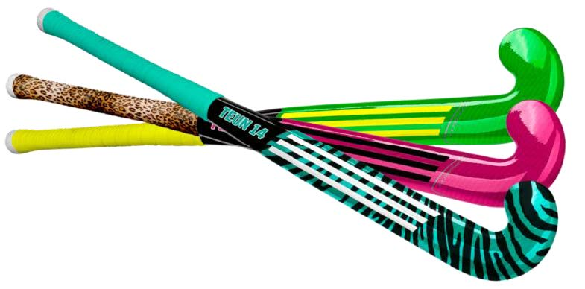 | Concrete
 | This stick is unique, a stiff synthetic stick containing 50% carbon. The “late bow” curvature gives you maximal control close to the body and is the ideal stick for both the offensive as well as the defensive player. The stick is suitable for both artificial turf and natural grass turf. This stick can be specially tailored enabling you to choose your own color composition and your favorite grip.
 | Abstract
 | This stick is characterized by its stylish, stiff synthetic composition, of which half is from carbon. The stick is very versatile, offers a lot of control, and is therefore ideal for maximum performances. Suitable for all field types. In addition there is the possibility to design your stick yourself for a contemporary result.

Note. Translated from Dutch; original materials in Dutch available upon request

Pretest Stimuli Study 2
Forty-one participants (all native Dutch, none participating in the main study), took part in the pretest. As in the pretest of Study 1, participants were first introduced with the same definition of abstract and concrete product communications. They were then randomly presented with both the concrete and abstract descriptions of the hockey stick and with the two slogans for the Dutch radio station 538 (concrete: “Radio 538, always close to you”; abstract: “Radio 538, everywhere within reach”) and were asked to rate the product description and the slogan on its level of concreteness (using the same measures as in pretest of Study 1). As intended, results demonstrated that both the descriptions of the hockey stick and the slogan differed significantly in level of concreteness: Hockey stick: M_{Conc} = 2.29, SD = 1.35; M_{Abst} = 5.29, SD = 1.23, t(40) = -8.27, p = < .001. Slogan: M_{Conc} = 3.20, SD = 1.54; M_{Abst} = 5.07, SD= 1.44, t(40) = -4.77, p = < .001.
A second pretest (N = 30, all native Dutch, none participating in the main study) established that both the product descriptions and the slogans did not differ in valence. The same procedure and measures were used as in pretest Study 1. Results showed that both the product descriptions and slogans did not differ in valence (hockey stick descriptions: p = .10; radio slogans: p = .21).

Web Appendix D
Descriptive Statistics of Study 2
Descriptive statistics for evaluation and purchase intention of the hockey stick as a function of communication type and uncertainty (Study 2).
 |  | Concrete |  | Abstract
 | Uncertainty | Uncertain  (N = 31) | Certain  (N = 30) | Uncertain  (N = 31) | Certain  (N = 32)
Outcome | N
Evaluation | 124 | 5.68 (1.14) | 4.97 (1.10) | 5.52 (1.03) | 5.34 (1.29)
Purchase intention | 124 | 5.65 (0.95) | 4.77 (1.59) | 5.00 (1.46) | 5.13 (1.34)

Notes. Mean (standard deviation).

Web Appendix E
Concrete and Abstract Product Descriptions and Pretest (Study 3)
Novel camera
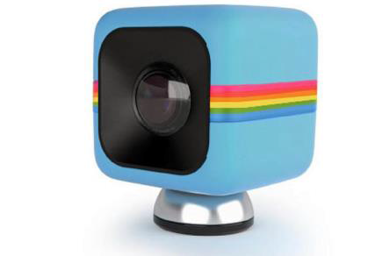 | Concrete
This is the new Cube camera.
This innovative camera takes clear pictures underwater and makes shock-free films while you are cycling. It has a strong magnet at the base, so you can place it on any metal surface. This tiny (35mm) camera supports Micro SD up to 32GB.
 | Abstract
Introducing the new Cube lifestyle action camera.
This innovative camera offers many great advanced features, no matter the condition you are in. With a magnet on the bottom, the Cube is designed to stick with you, so you can take it everywhere you want. With this 35 mm camera, Micro SD up to 32GB is supported.
Familiar camera
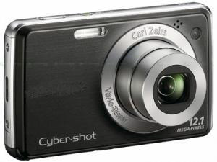 | Concrete
This is the Digital Camera DSC-W710.
The low pricing is one of the main features of this camera. In addition, this camera is very compact, so it can easily slip into your pocket. This is the most widely used camera, as it takes high-quality photographs.
 | Abstract
Introducing the Digital Camera DSC-W710.
This is an affordable camera; it doesn't break the bank to obtain. Due to its compactness, you won't feel too worried about bringing it along wherever you go. This camera is very popular because of its high-end possibilities.
Novel baby monitor
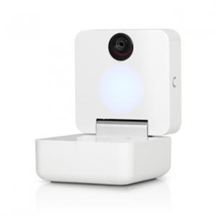 | Concrete
This is the new Smart Baby Monitor.
With this innovative Smart Baby Monitor you can not only hear and see your baby, you get to talk to your baby too. The Smart Baby Monitor offers advanced features, like a comforting light and night-time songs. Even though this monitor is the most advanced of its kind, it's easy to set up and to use.
 | Abstract
Introducing the new Smart Baby Monitor.
This innovative Smart Baby Monitor lets you keep contact with your baby using all possible senses. Beyond the traditional baby phone options the Smart Baby Monitor gives you many new and improved features. The monitor is a very advanced innovation, but is still user friendly.

Familiar baby monitor
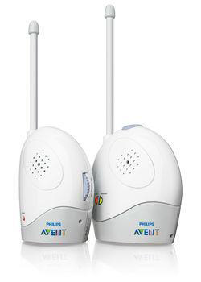 | Concrete
This is the Analogue Baby Phone.
With the Analogue Baby Phone, you will have a very reliable connection with your baby within 100 meters reach. This Phone delivers complete security with its crystal clear sound and comforting night-light for you and your baby.
 | Abstract
Introducing the Analogue Baby Phone.
The Analogue Baby Phone is the most reliable connection to your baby wherever you are in the house. Complete reassurance is delivered, as all the essentials of a baby phone are provided to be immediately there for your baby when needed.

Pretest Stimuli Study 3
A pretest (N = 136, students from a large University, none participating in the main study, randomly allocated to one of the products) was conducted to test whether the concrete and abstract descriptions differed in level of concreteness. We used the same procedure and measures as in the pretests of Studies 1 and 2, including the same definition of concreteness vs. abstractness. The results showed that the concrete descriptions were indeed perceived as more concrete than the abstract ones (familiar camera: M_{Conc} = 3.18, SD = 1.53 versus M_{Abst} = 5.09, SD = 0.98, t(32) = -6.12, p = < .001; novel camera: M_{Conc} = 2.72, SD = 1.68 versus M_{Abst} = 5.08, SD = 1.34, t(35) = -5.43, p = < .001; familiar baby monitor: M_{Conc} = 1.94, SD = 1.06 versus M_{Abst} = 4.85, SD = 1.18, t(32) = -9.71, p = < .001; novel baby monitor: M_{Conc} = 2.65, SD = 1.39 versus M_{Abst} = 5.62, SD = 1.39, t(33) = -7.89, p = < .001.
A second pretest (N = 116, US Prolific workers, none participating in the main study, randomly allocated to one of the products), using the same procedure and measure as in Studies 1 and 2, established that the concrete versus abstract product descriptions did not differ in valence (familiar camera: p = .27; novel camera: p = .48; familiar baby monitor: p = .58), except for the novel baby monitor, M_{Conc} = 6.07, SD = 0.87, M_{Abst} = 4.87, SD = 1.22, t(29) = 4.15, p < .001.
Web Appendix F

Study WA1 – Conceptual Replication and Generalization of Study 3 (additional study not included in the manuscript)

Study WA1 was set up to conceptually replicate and generalize the findings of Study 3. The study builds on and expands the findings in three ways: First, it tests the hypothesis using different stimuli. Second, instead of varying the product descriptions across the novel and familiar products as in Study 3, we kept in WA1 the slogans the same across the product novelty variable. Third, it used a more established scale to measure willingness to explore. We predict a significant 3-way interaction between product novelty, communication type, and willingness to explore new things, with a lower order significant 2-way interaction between communication type and willingness to explore new things for novel products, but not for familiar products.
Method
Participants and design
One hundred and seventy-one (79 females, M_{age} = 33.51, SD = 11.17) US Mechanical Turk workers took part in the study in return for a small monetary compensation. Respondents were randomly assigned to a 2 (product novelty: novel, familiar) x 2 (type of communication: concrete, abstract) factorial design. Participants who completed the experiment extremely fast or who took exceptionally long (more than 3SD below and above the sample mean, N = 3) were excluded from further analyses, leaving N =168 for final analyses. G*Power (Faul, Erdfelder, Lang, & Buchner, 2007) identified a sample size of 128 to detect a medium effect size of f = 0.25 with sufficient power (1-β > 0.80). We recruited more participants to account for potential drop outs and to ensure sufficient power in an online environment.
Stimuli
A novel and a familiar product in the product category cameras were selected. A pretest (N = 37, none participating in the main experiment) confirmed that the familiar camera was indeed perceived as less new (M = 2.27, SD = 1.66) than the novel camera (M = 6.11, SD = 0.99), on a scale ranging from 1 (‘familiar design’) to 7 (‘new design’), t(36) = 11.32, p < .001. The second pretest (N = 30, none participating in the main experiment) revealed, as predicted, that participants felt more uncertain regarding the usefulness and performance of the novel camera (M = 5.40, SD = 1.77) than the familiar camera (M = 2.73, SD = 1.70), t(29) = 5.60, p < .001, on a scale ranging from 1 (‘not uncertain at all’) to 7 (‘very uncertain’).
Two slogans, one concrete (“Captures all of your special moments!”) and one abstract (“Because all your special moments are worth it!”) were created. For this study (and contrary to Study 3) we used the same slogans for both the novel and familiar camera, keeping content equal across product novelty conditions. A separate pretest (N = 34, none participating in the main study), using the same procedure, definition of concreteness, and measures as in the pretests of Studies 1, 2 and 3, confirmed that the slogans differed in level of concreteness, (M_{Conc} = 3.29, SD = 1.80 versus M_{Abst} = 5.32, SD = 1.43), t(33) = -5.36, p < .001, but not in valence, p = .53.

Novel camera
Concrete | Abstract
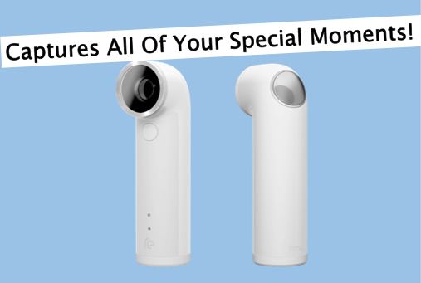 | 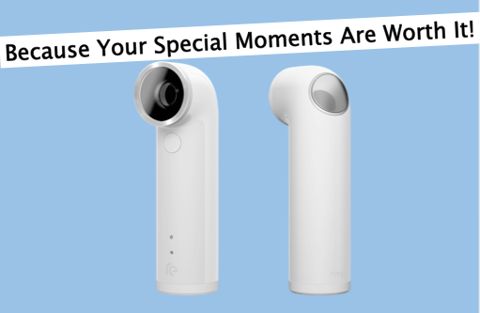
Familiar camera
Concrete | Abstract
 | 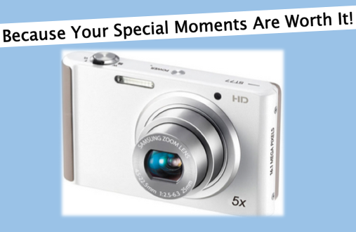

Procedure
General set up was the same as in Study 3. Participants were asked to imagine that they were planning to purchase a camera and while browsing a catalogue they saw an advertisement of either a novel or a familiar camera, with either the concrete or the abstract slogan presented above it. They were then asked to evaluate the advertised camera from 1 (very unattractive) to 7 (very attractive) and to indicate their willingness to buy the camera from 1 (not at all) to 7 (very much), as in Study 3. Again, these two items were highly correlated (r = .82, p = < .001) and were averaged into a single evaluation measure. After, participants’ willingness to explore was measured with a combination of the Exploratory Acquisition of Products scale (five items, i.e., “I enjoy taking chances to buy novel products just to get some variety in my purchase,” and “I would rather stick with a brand I usually buy than try something I am not very sure of” (reversed coded); Baumgartner and Steenkamp 1996) and the Open Processing Scale (five items, i.e., “I like to try different things” and “I often try new brands before my friends and neighbors do”; Leavitt and Walton 1975), ranging from 1 (‘strongly disagree’) to 7 (‘strongly agree’). The scale was averaged (α = .87, five items reverse coded) with higher scores indicating higher willingness to explore new things. Then, as a manipulation check, participants were asked to what extent they agreed with the statement “The camera shown above was unfamiliar to me”, ranging from 1 (‘strongly disagree’) to 7 (‘strongly agree’). Finally, they were asked to answer some demographics and thanked for their participation.
Results
Manipulation check
A t-test revealed that participants indicated that the novel product was perceived to be more unfamiliar (M = 6.30, SD = 1.19) than the familiar product (M = 4.94, SD = 1.53), t(166) = 6.46, p < .001.
Evaluation
The 3-way ANOVA including willingness to explore as continuous variable revealed a main effect of product novelty, F(1, 160) = 27.34, p < .001, η_{p}² = .15, of willingness to explore, F(1, 160) = 12.15, p = .001, η_{p}² = .07 and, consistent with Study 3, a significant 3-way interaction between product novelty, communication type, and willingness to explore, F(1, 160) = 4.13, p = .04, η_{p}² = .03. All other main and 2-way interaction effects were insignificant (ps > .10).
For the novel camera, we again regressed evaluation on communication type (-1 = concrete, 1 = abstract), willingness to explore (mean centered), and the corresponding two-way interaction. The regression showed, as expected, a significant interaction between communication type and willingness to explore, b = .41, SE = .18, t = 2.30, p = .02. To get a better insight into the interaction, spotlight analyses at one standard deviation below the mean of willingness to explore showed a negative and significant effect of communication type for participants who are less willing to explore new things, b = -0.62, SE = .25, t = -2.44, p = .02. The results show that when participants are less willing to explore new things, the novel camera is evaluated more positively when advertised with a concrete slogan (M = 3.34) than with an abstract slogan (M = 2.12). There was no effect of communication type for participants who were more willing to explore new things (one standard deviation above the mean), M_{Concrete} = 3.27 and M_{Abstract} = 3.69, b = .19, SE = .24, t = 0.79, p = .43 (see Figure WA1). For the familiar camera, the interaction between communication type and willingness to explore was insignificant, b = -.05, SE = .17, t = -0.28, p = .78.
Discussion

Consistent with Study 3, the results of this study demonstrate that novel products are liked more when advertised with a concrete rather than abstract slogan when people are less willing to explore new things. Communication type did not affect evaluation of novel products for people who are willing to explore new things. As they are more open for new and unfamiliar products, it is likely that they are less affected by the uncertainty that these types of products may activate.

Figure WA1. Evaluation of a novel camera (left panel) and familiar camera (right panel) as a function of communication type and willingness to explore.

Including all participants revealed the same pattern of results with a marginally significant 3-way interaction, F(1, 163) = 3.62, p = .059, η_{p}² = .02. Follow up regression analyses revealed for the novel camera an interaction between language and willingness to explore, b = .41, t = 2.32, p = .023. Again, participants who were less willing to explore evaluated the concrete slogan more positively than the abstract slogan, b = -0.61, t = -2.42, p = .018, but no such difference was found for participants who were willing to explore new products, b = .20, t = 0.84, p = .40. For the familiar camera, the interaction was insignificant, b = -.02, t = -0.12, p = .90.

